
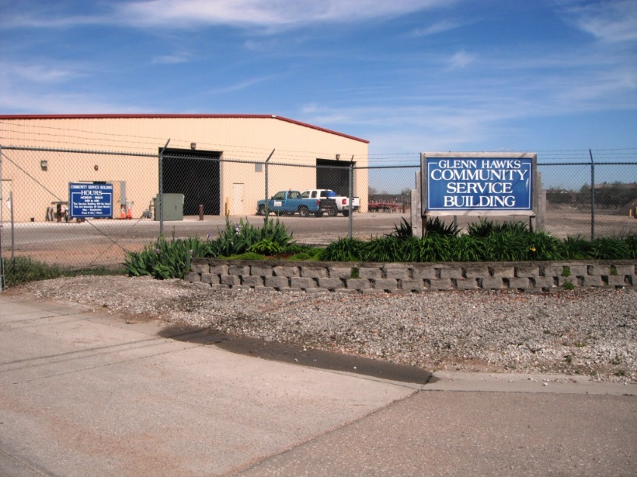

MCM #6

Municipal Good Housekeeping and Pollution Prevention (GHPP) Program

Version 1.1
July 2021

MCM #6 Municipal Good Housekeeping and Pollution Prevention Program

Table of Contents

Section 1 – Overview 3
1.1 Mission of the Good Housekeeping and Pollution Prevention (GHPP) Program 3
1.2 MS4 Permit Requirements 3
Section 2 – Municipal Facility Control and Inventory 6
Section 3 – Municipally-Owned Facility Assessment 8
Section 4 - Facility Runoff Control Plans (FRCPs) 9
4.1 Overview 9
4.2 Plan Elements 9
4.3 Development Process 10
4.4 Maintenance Facility Target Pollutant Identification 10
Section 5 – Roadway and Parking Lot Maintenance 15
5.1 Target Pollutants of Concern 15
5.2 Roadway Street Sweeping 17
5.3 Catch Basin Inventory
5.4 Catch Basin Cleanout
5.5 Parking Lot Sweeping
5.6 Records and Reporting Summary
Section 6 – Training and Education 23
6.1 Define Target Pollutants of Concern 23
6.2 Define Target Audience 23
6.3 Training Municipal Staff 23

List of Appendices

Appendix A: Lexington City Code, - Erosion & Sediment Control
Appendix B: SWPPP Checklist for Large Projects
Appendix C: SWPPP Inspection Report Template

– Overview

Mission and Goals of the Good Housekeeping and Pollution Prevention (GHPP) Program
The goal of the Good Housekeeping and Pollution Prevention Plan is to reduce the amount of pollutants in stormwater runoff from municipal operations and maintenance activities. The City of Lexington has multiple facilities and grounds that house departments which perform necessary operations for the municipality. Departments also incorporate the proper Best Management Practices (BMP’s) while performing these duties. The Good Housekeeping & Pollution Prevention Program describes these BMP’s. Some of these departments perform maintenance on machines-creating hazardous waste material

MS4 Permit Requirements
The City’s GHPP Program components are implemented based on requirements set forth in the City’s Small MS4 Permit: National Pollutant Discharge Elimination System (NPDES) Permit #3100003 – Authorizing Storm Water Discharges to Waters of the State from Small Municipal Separate Storm Sewer Systems (MS4), administered by the Nebraska Department of Environment and Energy (August 22, 2016). Part IV.B.3 describes requirements for Stormwater Best Management Practices for Good Housekeeping and Pollution Prevention:
a. Municipal Facility and Control Inventory
1) The permittee must develop and maintain an inventory of municipally-owned or operated facilities and storm water controls that is available for review by the permitting authority.
2) The permittee must identify on a map where the municipally-owned or operated facilities are located within the MS4. The map must be maintained and updated regularly and be available for review by the permitting authority.
b. Municipally-Owned or Operated Facility Assessment
1) The permittee must maintain current assessments of all municipally-owned or operated facilities identified in Part IV.B.5.a. The strategy and description of the assessment procedure must be included in the annual report.
2) The permittee must identify “high-priority” facilities that have a high potential to generate storm water pollutants. High-priority facilities means facilities owned or operated by the permittee that actively engage in one or more of the following activities: (i) composting, (ii) equipment storage and maintenance, (iii) materials storage, (iv) pesticide storage, (v) storage for public works, (vi) recycling, (vii) salt storage, (viii) solid waste handling and transfer, and (ix) vehicle storage and maintenance.
3) The permittee must document the results of the assessments and maintain copies of all site evaluation documents used to conduct the assessment.
c. Development of Facility-Specific Storm Water Management Standard Operating Procedures and Implementation of Facility Storm Water Controls (Runoff Control Plans, or RCPs)
1)The permittee must develop and maintain facility-specific Runoff Control Plans for “high priority” facilities to control the contribution of pollution in storm water runoff.
(a) For each “high priority” facility or operation identified in Part IV.B.5.b, the permittee must develop or maintain a site-specific RCP that identifies storm water control measures, inspection strategy, and visual monitoring procedures.
(b) A copy of the facility-specific Runoff Control Plan must be maintained and be available for review by the permitting authority. The RCP must be kept on-site at each of the municipally owned or operated facilities’ offices for which it was completed. The RCP must be updated as necessary.
2) All “high priority” municipally-owned or operated facility Runoff Control Plans must include provisions for general good housekeeping practices, storage of de-icing materials, fueling operations, vehicle maintenance, and equipment and vehicle washing.
d. Storm Sewer Maintenance Activities
1) MS4 storm water inlets and catch basin maintenance
(a) The permittee must develop a strategy to inspect and clean storm water inlets as needed in the SWMP. The results of the implementation of this strategy shall be included in the annual report.
(b) The permittee must have a plan to label inlets with a legible storm water awareness message.
(c) The permittee must visually monitor permittee-owned open channels and other drainage structures for debris and evidence of ongoing dumping in a strategy defined in the SWMP.
(d) The permittee shall include a plan for the removal of trash and debris from open channels and other drainage structures. The plan shall be detailed in the SWMP and approved by the NDEE. The permittee must document drainage structure maintenance activity in a log that is to be made available for review by the permitting authority upon request.
(e) The permittee must develop a procedure to dewater and dispose of materials extracted from catch basins so that water removed during the catch basin cleaning process and waste material will not reenter the MS4.
2) Municipal activities and operations
(a) The permittee must implement a set of pollution prevention measures that, when applied during municipal O&M activities, will reduce the discharge of pollutants in storm water.
(b) All pollution prevention measures implemented at municipal facilities must be visually inspected in a strategy defined in the SWMP to ensure they are working properly; a log of inspections must be maintained and made available for review by the permitting authority upon request.
3) Street Sweeping and Cleaning
(a) The permittee must sweep municipally-owned and maintained streets, roads, and public parking lots in accordance with a strategy defined in the SWMP.
(b) The permittee must provide a procedure to dewater and dispose of street sweeper waste material. This procedure must ensure that water and material will not reenter the MS4.
4) Maintenance of Municipally-Owned and/or Maintained Structural Storm Water Controls
(a) The permittee must inspect and maintain if necessary municipally-owned or maintained structural storm water controls in accordance with a frequency provided in the SWMP.
(b) The permittee must also maintain municipally-owned or maintained green infrastructure practices through regularly scheduled maintenance activities.
e. Training and Education
The permittee must develop and implement an employee training program for employees involved in implementing pollution prevention and good housekeeping practices in this part. The permittee must also identify and track all personnel requiring training and records must be maintained. The training program and target audience must be described in the SWMP.
f. Contractor Requirements and Oversight
Any contractors hired by the permittee to perform municipal maintenance activities that have the potential to impact storm water quality must be contractually required and overseen by the permittee to ensure compliance with all of the storm water control measures, good housekeeping practices, and facility-specific Runoff Control Plans described above. The contract must also state who is responsible for overall management and implementation of your pollution prevention/good housekeeping program and, if different, who is responsible for each of the BMPs identified for this program.

– Municipal Facility Control and Inventory
The City of Lexington has developed and maintains an inventory and map of municipally owned or operated facilities within the City Limits and extraterritorial jurisdiction (ETJ). The inventory is maintained in conjunction with Municipal Facilities Assessments. Figure 1 is the current Municipal Facilities Inventory.
Figure 1: Municipal Facility Inventory
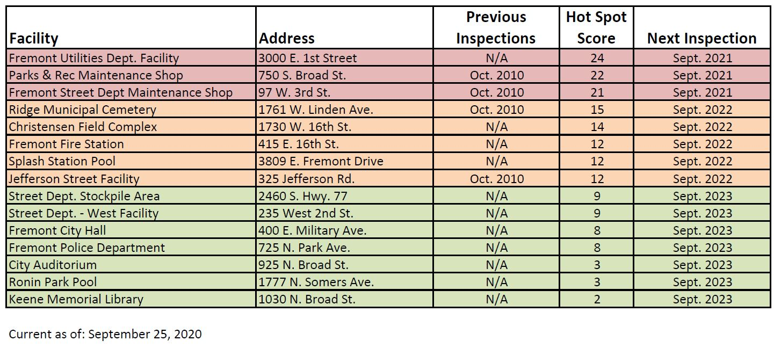

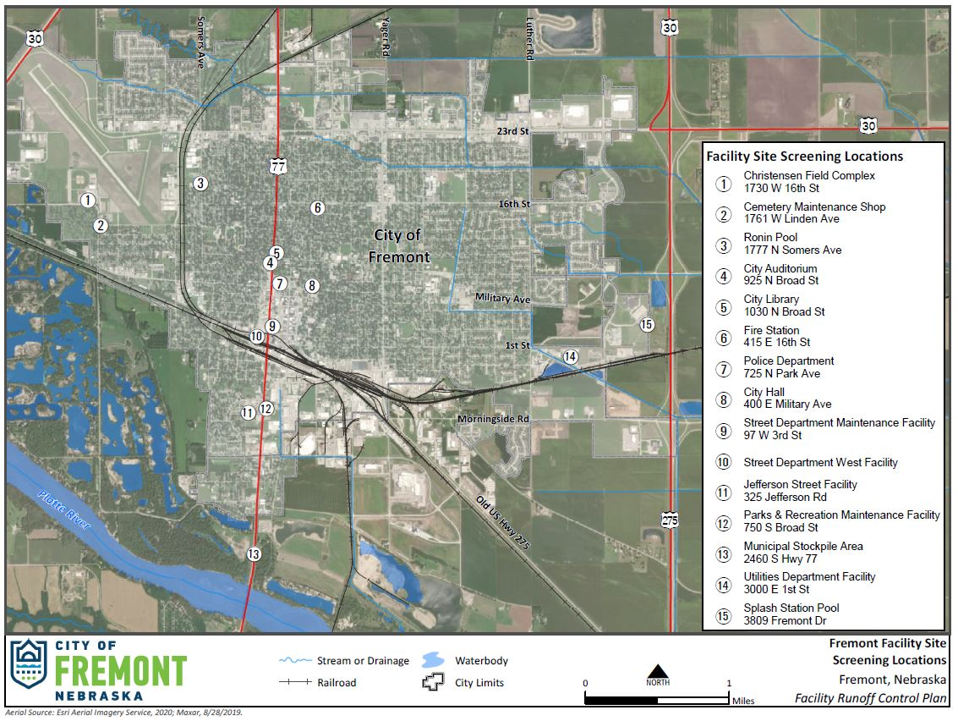
Figure 2: Municipal Facility Locations Map

– Municipally-Owned Facility Assessment
The City maintains current assessments of all municipally owned or operated facilities identified by activities conducted at these facilities as having the potential to contribute to stormwater pollution. The City conducts municipal “hot spot” evaluations to identify facilities with activities or physical features posing a higher risk for pollutant loading impacts. The following Hot Spot Evaluation is performed at each identified facility. Based on the frequency of ten (10) municipal operations activities conducted at the facility, a score is given for each activity, which is then added to provide the facility with a final evaluation score. The municipal activities assessed for frequency are the following:
- Vehicle & equipment maintenance and repair (excluding small engine repair)
- Vehicle & equipment fueling (bulk fuel storage capacity – stationary or mobile)
- Vehicle & equipment washing (particularly outdoor washing)
- Vehicle & equipment storage (outdoor)
- Outdoor loading & unloading
- Outdoor material storage (stockpiles & bulk storage)
- Dumpster/trash compactors for waste management
- Building & grounds maintenance (i.e., trench drains, sumps, oil/water separators, stormwater drainages
- Parking lot maintenance (i.e., sweeping, paving, grading)
- Turf management and landscaping maintenance (i.e., fertilizer and pesticide management, mixing, storage)
Based on the facility “Hot Spot” Evaluation score, the following results and actions are as follows:
Score | Result | Action
>20 | Hot Spot | Facility Runoff Control Plan (FRCP) Required
10-20 | Potential Hot Spot | Targeted Education & Policy (Consider FRCP)
<10 | Not a Hot Spot | Targeted Education

- Facility Runoff Control Plans (FRCPs)

Overview
A Facility Runoff Control Plan (FRCP) document describes how City maintenance facility staff will protect the quality of stormwater leaving a maintenance facility using good housekeeping and pollution prevention methods. Good housekeeping and pollution prevention methods are largely based on personal actions and planning efforts described as non-structural Best Management Practices (BMPs). Implementation of effective non-structural – action based – BMPs is the primary focus of site specific FRCPs.
This Facility Runoff Control Plan (FRCP) supports the City of Lexington’s stormwater management program. The document provides education, inspection, and corrective action guidance for the Maintenance Facilities to help implement the Good Housekeeping/Pollution Prevention Measures required of the City. Facility staff can use the site-specific information provided in this document to:
- Conduct inspections required by the City,
- Identify potential target pollutants and sources, and
- Take personal actions for managing pollutants and sources.
Facility Good Housekeeping/Pollution Prevention inspections will be conducted by Qualified Facility Inspectors quarterly each year at approximately 90-day intervals using the form provided in this FRCP. A Facility Inspector is considered qualified at the discretion of the FRCP Development Team. At a minimum, a Qualified Facility Inspector will have read the FRCP; be familiar with, if applicable, any Spill Prevention, Control, and Countermeasure (SPCC) Plans; receive a briefing from a Qualified Facility Inspector on the inspection process; and participate in Stormwater Pollution Prevention Training when offered by the City.

Plan Elements
A site specific Facility Runoff Control Plan (FRCP) is developed from a standardized selection of target pollutant information. Each FRCP is tailored to target the potential pollution sources and discharge locations at each facility. To keep information organized, each FRCP will be kept in a three-ring binder at the maintenance facility it was developed for. Site specific details in the FRCP will include the following information:
- A Title Page that identifies the facility name and the date of the most recent version
- A Vicinity Map that identifies adjacent land uses and receiving waters
- An Overview of the major facility operations
- Identification and description of Target Pollutants and Pollutant Sources
- A detailed Site Map that corresponds with the Inspection Checklist and Instructions
- Blank Corrective Action Logs after facility inspections

Development Process
An FRCP is developed for each facility identified as a “Hot Spot” in Figure 1. A description of the development process is described below.

Facility Evaluation and GHPP & Stormwater Education
A facility walkthrough is conducted to provide the FRCP development team an opportunity to ask questions about specific site conditions as well as propose hypothetical conditions to determine how the facility is operated and maintained. The walkthrough is a good time to allow facility staff to ask questions about alternative good housekeeping/pollution prevention techniques that may be of interest. The FRCP development team will document the site thoroughly with field notes and digital photographs for reference back at the office. Facility staff should provide any helpful questions or thoughts before the initial visit is completed.

Draft FRCP Delivery and FRCP Training
The FRCP development team will deliver the Draft FRCP and conduct the FRCP Inspector training for staff that will be responsible for conducting FRCP inspections at the facility. All staff members completing the training will be included in the FRCP as a Qualified Inspector. Training is discussed further in Section 4.4 of this document.
The training materials for FRCP Inspector training will be the Draft FRCP for each facility. The FRCP development team will conduct the first site inspection with the site inspectors and facility supervisor, allowing them to get a feel for the FRCP and learn the expectations for documentation and verification. This second facility visit by the FRCP development team will conclude with a question and answer session.

Final FRCP Delivery
The FRCP Development Team will finalize the FRCP document within a month the initial Draft FRCP training and inspection The final FRCP will be provided to the facility to maintain on-site. Any substantial changes to the facility, staff, procedures, or materials after the FRCP has been finalized must be noted by hand in the FRCP until a revised edition can be made. All revisions in the FRCP should be initialed and dated in the facility’s master copy of the FRCP.

FRCP Updates
Updates can be made for various reasons. There is currently no requirement for updating an FRCP. Facility inspectors are encouraged to make minor modifications to the document by writing in the change and initialing the change with a date. If requested, the FRCP Development team can make a formal update and send changes to the facility with a new revision number and date listed on the cover sheet.

Maintenance Facility Target Pollutant Identification
Each FRCP is developed with the primary focus placed on enabling facility staff to easily identify potential problems and take actions that reduce the risk of stormwater pollution. The first step in this process is to identify the most common target pollutants that can be found in maintenance facilities. Every facility will have unique conditions and target pollutants, but Section 4.4.1 identifies the most common target pollutants that can be expected. The second step is to group major maintenance facility activities with potential to contribute to the discharge of the target pollutants. Section 4.4.2 identifies the five target pollutant categories that are used in each FRCP.

Target Pollutants

4.4.1.1 Petroleum and Vehicle Fluids
Petroleum products (e.g., gasoline, diesel fuel, motor oil and other lubricants), antifreeze, and hydraulic fluids are common pollutants deposited on the ground at maintenance facilities. Many of these products may contain special additives, which may be toxic to humans and aquatic life. Potential sources of these products at maintenance facilities include leaks from vehicles and machinery and vehicle maintenance activities such as fueling, changing oil and washing.

4.4.1.2 Pesticides
A pesticide is a chemical agent designed to control pest organisms. The most common forms of pesticides are organic chemicals designed to target insects (insecticides) or vascular plants (herbicides). Pesticides are routinely detected in surface waters largely because water is one of the primary media in which pesticides are transported from targeted applications – the pest – to non-intended parts of the environment. Using pesticides for chemical weed control and integrated pest management activities requires storage at maintenance facilities which can become a potential source of pollution if managed improperly.

4.4.1.3 Metals
Dissolved and suspended metals are found in stormwater runoff above a certain threshold may harm aquatic life. These metals come from various sources and activities, including fuel combustion, brake pad wear (copper), tire wear (cadmium and zinc), metal corrosion, pressure-treated wood and creosote posts used for guard rails (arsenic), paints, herbicides and other materials. Maintenance facilities become a central location for much of the materials and equipment that can be a source of dissolved and suspended metals in stormwater.

4.4.1.4 Sediment
An amount of sediment transported by stormwater in excess of natural concentrations is considered a pollutant. Additionally, potential pollutants (e.g., metals and nutrients) attached to sediment particles are transported with the sediments to receiving waters and increasing the potential for water quality impacts. Potential sources of sediment in runoff from maintenance facilities include tracking, transport and storage of loose bulk materials (e.g., sand or other aggregate), grading-related activities un-vegetated soils, and soil erosion.

4.4.1.5 Litter and Debris
Litter and debris in stormwater accumulate in the manufactured form of paper, aluminum cans, Styrofoam, plastic waste products and other items commonly discarded inappropriately. These pollutants can be transported by wind and stormwater into the storm drainage system which becomes a low-lying catchment. Litter and debris is often brought to maintenance facilities after street sweeping, storm drain maintenance, and right-of-way cleanup activities. Litter in surface waters can inhibit the growth of aquatic vegetation, harm aquatic organisms by ingestion or entanglement, convey other pollutants, such as toxic substances and cause aesthetic problems on shorelines of ponds and lakes. In addition to impacting water quality, these items may obstruct the stormwater drainage system and cause property damages.

4.4.1.6 Nutrients
Nutrients include any substance taken up by living things to promote growth. The term generally applies to nitrogen and phosphorus, but is also applied to other essential trace elements less commonly used. Excessive amounts of nutrients that make their way to receiving waters can over-stimulate the growth of aquatic plants causing extreme algal blooms leading to low dissolved oxygen levels and can result in fish kills, foul odors, and limited public use. Some of the possible sources of nitrogen and phosphorous from maintenance facilities include storage of fertilizers, decaying plant materials from tree trimming, vegetation management surfactants and emulsifiers and natural sources such as the mineralized organic matter in soils.

4.4.1.7 pH
The pH of a water sample is a measure of its acidity (acid) or alkalinity (base). Water that is acidic or alkaline may causes harm to aquatic organisms or consumers of the water, and may even result in damage to equipment and materials. Maintenance activities that may change the pH of runoff include the storage of batteries holding battery acid, parts washing and management of concrete wastes.

4.4.1.8 Pathogens
Pathogenic microorganisms, such as viruses and bacteria, can be extremely variable in natural conditions making them difficult to measure and control. A group of pathogenic microorganisms known as coliform is commonly measured as an indicator of the potential presence of pathogens with fecal origin which can cause significant health issues in humans and other water consumers. Sources of total and fecal coliforms in stormwater runoff are everywhere (e.g., soil microorganisms, wild and domestic animal droppings, etc.). Maintenance facilities must control specific sources of coliform from any pet wastes, non-permitted sewer connections to a storm drain or receiving stream, seepage from septic tanks and spillage from portable toilets.

4.4.1.9 Chloride and Sulfates
Winter roads maintenance requires the use of chemicals and abrasives in large enough quantities to keep roadways safe for travel. Maintenance facilities store large quantities of sand and salt in preparation for use during storm events. To prevent salts from caking, a variety of chemicals are added to the stockpiles. Chlorides, sulfates, and cyanide are all dissolved substances that may be toxic to receiving waters in strong enough doses. Chlorides and sulfates will typically runoff during rain events from unmanaged maintenance facilities eliminating stream channel vegetation which is essential for a healthy aquatic ecosystem and the prevention of stream bank erosion.

Target Source Categories

Building and Grounds Maintenance
Maintenance facilities require building and grounds management, which includes care of landscaped areas around each facility, cleaning of parking areas and pavements, and maintenance of the stormwater drainage system. Tasks to perform these activities include equipment operation, litter/trash pickup and maintenance landscaping, which can in turn result in spills, leaks, trash, sewage, erosion and chemical vegetation control. Potential target pollutants could include sediment, litter, trash, sewage, pesticides, fuel, hydraulic fluid and oil. Buildings and grounds must be maintained in a manner that reduces the risk of discharging pollutants to the stormwater drainage system.

Vehicle and Equipment Management
Maintenance facilities are the regional staging areas for all vehicles and equipment used to operate and maintain roads and properties owned by NDOR. All vehicles and equipment require operation and management of some type, which may include storage, fueling, cleaning, maintenance and repair. Haphazard management actions can quickly lead to substantial spills, leaks, and non-stormwater discharges. Vehicle fluids at fueling areas as well as equipment washing, storage, and maintenance areas must be managed to reduce the risk of discharging pollutants to the stormwater drainage system.

Product Material Management
Maintenance facilities store a large variety of products that could be harmful to the environment if they come into contact with surface waters. Materials that may be stored include pesticides, petroleum products, paints, concrete and asphalt products, and solvents.

4.4.2.3 Product Material Management
Storage and handling practices that minimize exposure of these materials to stormwater can significantly minimize the potential for receiving water contamination. Large stockpiles of materials located on maintenance lots require responsible management just as much as products that are stored indoors or under cover. All product materials must be managed to reduce the risk of discharging pollutants to the stormwater drainage system.

Bulk Storage Tank Management
Bulk storage tanks full of stock products are a typical feature of most maintenance facilities and they generally come in all shapes and sizes. Substances contained in storage tanks may include soil stabilizers, dust suppressants, herbicides, fertilizers, de-icing chemicals, fuels, lubricants and other petroleum products. A Spill Prevention Control and Countermeasure (SPCC) plan may be in place to reduce the risk of pollution from certain petroleum products but all bulk storage tanks generate a certain level of risk of discharge to adjacent drainages and receiving waters. Storage tanks must be protected and maintained in a manner that reduces the risk of discharging pollutants to the stormwater drainage system.

Waste Material Management
Waste management is governed by both federal and state requirements which include Federal hazardous waste management regulations developed under the Federal Resource Conservation and Recovery Act (RCRA), state-level waste management regulations, and regulations developed under other statutes that apply to wastewater discharges and air emissions. Maintenance facilities must comply with federal and state waste management regulations and take measures to reduce or eliminate waste streams in order to reduce any present and future threat to human health and the environment. Hazardous wastes must be managed to reduce the risk of discharging pollutants to the stormwater drainage system.

– Enforcement Response Plan
The City of Lexington uses an Enforcement Response Plan (ERP) and Codes written into our City Code to ensure that our Construction Stormwater Program is followed. The following sections these documents. City of Lexington sMS4 Permit requires the development and implementation of adequate enforcement authority for construction activity that takes place within the boundaries of the City Separate Storm Sewer System (MS4). The purpose of this Enforcement Response Plan is to communicate how the enforcement tools available to the City will be used to achieve compliance. The Enforcement Response Plan also specifies criteria by which City personnel can determine the enforcement action most appropriate to instances of non-compliance. This plan is a document of the City's procedure to be followed when a construction stormwater violation is discovered.
The procedures are developed with the following objectives in mind:
- The City is not responsible for enforcing the Nebraska Department of Environment and Energy (NDEE) Construction Stormwater Permit.
- Prevent pollutants from entering the MS4 and causing environmental harm.
- Ensure that violators return to compliance in a timely manner.
- Communicate definitions for non-compliance.
- Penalize non-compliant construction site operators for violations.
- Provide equitable and consistent enforcement actions to the extent possible.
- Deter non-compliance through education and compliance assistance first and, if necessary, penalties second.
- Recover costs incurred by the City due to construction site operator non-compliance.
Nothing in this plan shall affect the City’s authority to bring enforcement actions for violations pursuant to any portion of the City Ordinance.

Criteria to Decide Type of Violation
The enforcement process begins by identifying a construction site operator’s violation. Once a violation is identified it must be determined whether the violation should be considered significant or non-significant. Next, the most appropriate response is determined. Each violation must be documented even if the decision is to take no action. Documentation must explain why such action was/was not taken.
To determine if a violation is significant or non-significant the following criteria must be considered:

Magnitude
Generally, a minor isolated instance of non-compliance can be considered non-significant and dealt with by informal responses, such as a Personal Contact or Phone Conversation (PC) or notice of violation (NOV).

However, some isolated incidents may cause damage to the MS4 and/or the health and welfare of the public and city personnel. Situations like these would be significant and necessitate a formal enforcement action such as a Stop Work Order (STOP) or an Administrative Order (AO).

Duration
The construction site operator will be subject to escalated enforcement actions if violations, regardless of severity, continue over prolonged periods of time. Chronic violations and/or failures to comply with administrative orders will be considered significant violations and may result in enforcement actions including, but not limited to, termination of permits, fines and/or court orders.

Effect on the Environment
One objective of City Code 11-723.04.B is to prevent pollutants from entering the MS4 and/or entering a receiving waterbody and causing environmental harm. Environmental harm will be presumed whenever a construction site directly discharges pollutants into an adjacent receiving waterbody or fails to implement BMPs that prevent sediment form leaving the site and entering the City’s MS4. These violations will be considered significant.
At a minimum, responses to these circumstances require issuance of an Administrative Order (AO) and possible issuance of Administrative Fines (AF).

Compliance History of the Operator
The industrial operator's compliance history will be an important factor in determining the appropriate remedy to apply. The city has the authority to issue informal notices for the less severe violation if the violator has a good compliance history.
Recurring violations by an industrial operator may indicate that their treatment system is inadequate or that the operator has taken a casual approach to operating and maintaining its treatment system.
Chronic compliance problems such as late reports and missing sample collections indicate a disdainful attitude and the possibility of future significant violations.

Good Faith of the Operator
`Good Faith' is defined as the operator's honest intention to remedy its non-compliance evidenced by actions which give support to this intention. Good faith shall be demonstrated by cooperation and completion of corrective measures in a timely manner. Compliance with a previous enforcement order is not in itself necessarily good faith.
The construction site operator’s good faith in correcting its noncompliance is a factor in determining which enforcement response is suitable. However, good faith does not eliminate the construction site operator from enforcement action. For example, if the City must pay to install necessary Erosion and Sediment Control (ESC) measures, it should recover its costs regardless of prior good faith.
Once the severity of the violation is determined, it will then be necessary to initiate the proper response.

Types of Responses
There are three types of enforcement responses:
Informal - may be a telephone contact, personal contact, or a notice of violation (NOV) when violations are non-significant or when the construction site operator is cooperative in resolving the problem.
Formal - may be an Administrative Order (AO) or Administrative Fine (AF) when the construction site operator does not promptly undertake Corrective Actions (CA) or has recurring violations.
Judicial - Civil or criminal prosecution when a violation is significant and/or the construction site operator is uncooperative.
The enforcement response selected must be appropriate to the violation. For example, telephone calls are appropriate for late reports or BMPs that need maintenance, but failure to receive approval for construction activity or failing to install BMPs would require a more immediate and stringent response. Knowledge of requirements and intent to cause violation by the construction site operator should be considered when determining the severity of the action to be taken.

Informal
The City will pursue compliance assistance through multiple, informal methods whenever reasonable. These methods are appropriate for situations where education is needed, violations do not pose a significant danger to human health or the environment, or the City believes that compliance can be achieved by measures described below. Use of informal measures often establishes the documentation trail necessary for formal enforcement action and should therefore be sufficient to support the burden of proof.

Telephone/Personal Notification
Telephone contact or personal contact with the construction site operator may be chosen to obtain information and resolve isolated or infrequent violations. The contact will take place within 24 hours of determining a violation. Prompt responses will demonstrate to the construction site operator that the city is serious about enforcing construction program requirements. It also helps to deter future violations.

5.2.1.2 Refusal of City Inspections
Required inspections – such as those associated with a building permit or other approved activity – may be refused by the City Inspector when any the following conditions exist:
- the construction site does not have a posted Notice of Intent (NOI),
- perimeter controls are not installed or are dysfunctional, or
- evidence of discharged sediment or other pollutants exists outside the construction area.
At a minimum, the inspector refusing inspections will notify the City Engineer of the situation and will document the following information: date/time inspection refused; the party notified on-site, and the substance of the conversation including what specific actions must be taken before the inspection can be conducted.
At a minimum, the conversation shall be documented with the following information: date/time call placed; the person contacted, and the substance of the conversation.

5.2.1.3 Notice of Violation (NOV)
The NOV is an official communication from the City to the non-compliant construction site operator which informs the party that a violation has occurred. It is issued for relatively minor or infrequent violations of the ordinance standards and requirements.

The NOV will provide the construction site operator with an opportunity to correct noncompliance on their own initiative rather than according to a schedule of actions determined by the City. It is a prompt response to violations and documents the initial attempts of the City to resolve the noncompliance.

The NOV shall contain the following information:

- the specific violation that has occurred,
- specific actions required to return to compliance, and
- warning that further enforcement action may be taken for failure to comply.

NOV's shall be sent via certified mail/return receipt or hand delivered within three (3) working days after discovery of the violation.

A template Notice of Violation Letter is included with this document as Appendix D.

5.2.1.4 Stop Work Order (STOP)
The STOP is a notice posted by the City on the construction site which informs the operator that a violation is ongoing and no work is allowed to continue until it is resolved. It is the last tool available to the City before formal enforcement proceedings are taken. The STOP is posted for failure to respond to a NOV or for relatively moderate/significant violations of the ordinance, standards or requirements that require immediate action.
The STOP will require the construction site operator to contact the City Engineer to explain what must be completed before work is allowed to continue. The STOP may not be removed by anyone other than a designated representative of the City.
The STOP shall contain the following information:
- the ordinance that has been violated,
- contact information of the CITY ENGINEER,
- date by which the SWMP must be contacted, and
- warning that failure to comply will result in formal enforcement actions.

Formal
When required to address willful non-compliance by a construction site operator or immediate threats to human health and the environment, the formal procedures described below can be taken to resolve construction stormwater non-compliance.

Administrative Order
An administrative order will be a formal order issued by the City to the construction site operator in noncompliance. It will direct the construction site operator to undertake corrective measures or cease specified activities.

Consent orders will be issued when the construction site operator has significant discharge violations or failed to comply with other enforcement responses. In some cases judicial proceedings may be more appropriate.

There are four types of administrative orders:
- Compliance orders - A compliance order directs the operator to restore compliance by a specified date. The order will document the noncompliance and state required actions to be completed by the operator and the dates by which the actions must be completed to eliminate the noncompliance.

The city will track the operator's performance to ensure that the operator is making acceptable progress. This will be accomplished by requiring the construction site operator to submit progress reports, conduct monitoring requirements, perform additional site inspections, etc. as necessary to verify compliance is achieved.

Issuance of a compliance schedule does not necessarily relieve the operator of having to meet its existing erosion and sediment control commitments, nor protect the operator from having additional fines levied for other violations during the compliance schedule period.

- Consent Order - The consent order will permit the flexibility of a negotiated settlement between the City and the construction site operator. The order will be comprised of compliance schedules, stipulated fines, or other provisions as deemed necessary, and signatures of City and operator representatives.

- Cease and Desist Order - A cease and desist order shall be used in situations where the non-compliant operator's discharge could result in significant environmental harm or impact human health, safety or welfare.

A cease and desist order may be issued by telephone. A subsequent written order shall be served either in person or by registered mail to the construction site operator. If the operator fails to comply with the order, the City may pursue additional steps to halt the discharge, such as, seeking injunctive relief or blocking the invoking police power.

- Show Cause Order - An order to show cause or directs the operator to appear before the City and explain why more severe enforcement actions should not be taken (e.g.: termination of service). A hearing will be conducted by a designated City representative (i.e. Attorney, City Council or Public Works Director, a hearing officer) or by a review board.

The hearing may be formal or informal and it may be open or closed to the public.

The hearing shall determine if further action is warranted and, if so, its nature and extent.

Fines
An administrative fine is a monetary penalty assessed by the City to the construction site operator for a violation of City Ordinance, policy and/or standards. The fine may be assessed at the City's discretion and the amount of the fine may be determined on an individual basis.

The fine is considered punitive in nature and is not related to any specific cost borne by the City. The amount of the fine should be proportional to the harm caused by the violation. The City shall also recover damages to its MS4 or for the cost of stabilizing a construction site as stated at City ordinance 5186, Section 14..

Termination/Suspension
The City has the authority to revoke an approved development plan, building permit and/or other City-issued permit associated with an approved erosion and sediment control plan. These actions may be used against owners that fail to comply with previous administrative orders, or to prevent or stop discharges that are considered to pose an immediate or serious hazard or significant environmental damage.

Judicial
A judicial action is a formal enforcement action that involves a court. The action may be civil litigation, criminal prosecution, or both.

Civil Litigation
Civil litigation will be used as an appropriate enforcement response to the following situations:
- Injunctive relief is necessary to halt or prevent activities or non-stormwater discharges that threatens human health, the environment or the MS4,
- Efforts to restore compliance through less formal actions have failed,
- The construction site operator fails to pay assessed fines,
- The City determines it needs to recover losses due to the construction site operator’s noncompliance.

The following describes three types of civil litigation:
- Consent Decrees are agreements between the City and the construction site operator reached after a lawsuit has been filed. To be binding, the decree must also be signed by the judge assigned to the case.
- Injunctions are court orders which direct parties to do something or refrain from doing something. The City may be forced to seek injunctive relief if the construction site operator refuses to comply with an administrative order or if delays in filing a civil suit would result in irreparable harm to the MS4 or receiving waterbody.
- Civil Suits may be necessary to recover costs borne by the City in responding to the operator's noncompliance.

Criminal Prosecution
Criminal prosecution is a formal process of charging individuals and organizations with violations of ordinance provisions that are punishable, upon conviction, by fines and/or imprisonment.

Criminal prosecution is an appropriate enforcement action when there is evidence of willful noncompliance and when criminal negligence or intent can be proven. Some examples of these are altering or falsifying reports, tampering with samples, unauthorized discharges, and violations of administrative orders.

The criminal enforcement process begins when the City has reason to believe crimes have been or will be committed. This information may be gathered during routine inspections or monitoring/sampling activities or in the form of reports from employees or the public. Citations may be issued where it is determined the operator’s efforts, or lack thereof, to obtain compliance through less formal actions have failed. If crimes are suspected or known, the City Administrator shall notify the City Attorney for proper collection of evidence.

Enforcement Responsibilities
When a construction site operator violation is suspected or discovered, the City Engineer, or person designated by the City Engineer, shall be responsible for informal actions such as:
- Identifying and documenting the violation,
- Telephone notification,
- Notice of Violation letter,
- Sampling, monitoring and inspecting,
- Follow up actions.

All significant violations and the responses shall be reported to the City Engineer and/or the City Administrator.

The City Administrator and City Attorney will be copied on all formal Enforcement Responses. The City Engineer will consult with the City Attorney and City Administrator in Judicial Actions

– Training and Education

Define Target Pollutants of Concern
The City of Lexington has clearly defined the term ‘Pollutant’ multiple times in City Code. As it relates to Construction Stormwater, the definition is unchanged. City Code 11-723.04.B defines “Pollutant,”
Pollutant: Anything which causes or contributes to pollution. Pollutants may include, but are not limited to: paints, varnishes, and solvents; oil and other automotive fluids; non-hazardous liquid and solid wastes and yard wastes; refuse, rubbish, garbage, litter, or other discarded or abandoned objects, Codes, and accumulations, so that same may cause or contribute to pollution; floatables; pesticides; herbicides, and fertilizers; hazardous substances and wastes; sewage, fecal coli form and pathogens; dissolved and particulate metals; animal wastes; wastes and residues that result from constructing a building or structure; wastes and residues that result from mobile washing operations; and noxious or offensive matter of any kind.
As it pertains to Training and Education for the Construction Stormwater Program, Target Pollutants will be taken from this definition and associated with their Target Audiences.

Define Target Audience
The City of Lexington has employees that deal with the development community on a daily basis. These employees are responsible for inspections of development projects of varying sizes from small lot construction to Municipal/Capital Improvement Projects. At times, these employees are telling contractors/developers what is acceptable or not as Erosion and Sediment Control (ESC) Best Management Practices (BMPs). The two positions the City employs to do this are:
- Assistant City Engineer, Public Works Department
- Erosion and Sediment Code Inspector(s), Building Department

Training Municipal Staff
Erosion and Sediment Control Code inspectors must meet the minimum standards of a “qualified inspector” as stated in the NPDES Construction Stormwater Permit and the City of Lexington Municipal Code. This means that all ESC inspectors will attend training recognized, approved or sponsored by the NDEE regarding Erosion and Sediment Control. All Code Inspectors will attend two (2) meetings with the Stormwater Program Manager to discuss inspections, findings, and problem areas.
In general, qualified inspectors are knowledgeable in the principles and practice of erosion and sediment controls and possess the skills to assess conditions at the construction site that could impact stormwater quality and to assess the effectiveness of any erosion and sediment control measures selected to control the quality of stormwater discharges from the construction activity.

Outline of Target Messages to convey in Training & Education
The City of Lexington has several messages it tries to convey during its training and educational processes. The biggest challenge is identifying target audiences and ensuring that the message directed towards them is appropriate for the service they perform.
1. Municipal Employees
a. Spill Response Plan
b. Illicit Discharge Response & Cleanup
c. Department-Specific BMP’s
2. General Contractors
a. Erosion and Sediment Control BMP’s
b. Procedural information
c. New programs
3. Trade Contractors
4. General Public: Only Rain Down the Drain
a. Children
b. Adults

Delivery of Training & Education

Municipal Staff
The City of Lexington targets specific departments when it considers which employees to train and targets all City employees when it comes to education. For Construction Stormwater, the training consists of several formats, but primarily is one-on-one discussions about policy and procedure. City staff attend regional Erosion & Sediment Control Inspector Certification classes on a regular basis and attend other stormwater conferences and workshops annually.

Developers & Designers
The City of Lexington works to develop relationships with local developers and designers. During interactions with the design community, City staff will inform them any changes or new programs that are upcoming. When the City of Lexington amends City Code it is at City Council meetings, the agenda is made clear to the public in advance. When Code amendments are presented, the public can make comments or ask questions.

General Contractors
Site Inspections provide the opportunity to educate construction site operators about required actions, document compliance issues, verify that City standards are being met, and initiate enforcement actions when required.

General Public
As part of compliance with the NDEE NER310000 MS4 Permit, the City of Lexington conducts Public Education and Outreach, providing educational materials to the community about impacts of polluted stormwater discharges on water bodies and the proper steps the community can take to minimize pollutants in those discharges. The general public is an essential component in improving stormwater pollution. Creating communication opportunities between professionals with knowledge of stormwater issues and the public is a key in increasing their awareness on the subject.
For the City of Lexington to get an idea of how much the public knows about the efforts being undertaken, several types of interactions can be performed, including: social media posts, public service announcements, newspaper articles, commercials, websites, and radio interviews. These activities identify specific Target Pollutants dependent on Target Audiences being addressed.

Appendix A –

Appendix B –

Appendix C –

Appendix D –

