

**Nebraska Department of Environmental Quality**

**Authorization to Discharge Under the NPDES Storm Water Phase II Municipal Separate Storm Sewer System (MS4) General Permit**

**Authorization No. NE 300003**

**City of Lexington**

**Phase II MS4 Annual Report**

**For Reporting Period: 01/01/16 through 12/31/16**

**Executive Summary**

In August 2005, the City of Lexington submitted the Notice of Intent for coverage under the NDEQ General Permit for Phase II Municipal Separate Storm Sewer Systems (MS4) Discharges for Small Cities within the State of Nebraska. Lexington also submitted portions of the Storm Water Management Program (SWMP) as required by the permit. The SWMP identifies the MCMs and the BMPs, measurable goals, and implementation schedules for the MCMs. The permit requires the submission of an Annual Report to the NDEQ for each permit year within sixty (90) days after the anniversary date of the permit coverage which commenced on January 1, 2006 for Lexington. As required by the permit, Lexington evaluated the implementation of the BMPs for each MCM and assessed the overall compliance with the MCMs.

This annual compliance evaluation report fulfills the MS4 permit requirement to assess compliance with permit conditions, appropriateness of Best Management Practices (BMPs), and progress towards statutory goals of the permit and Measurable Goals established for each Minimum Control Measure (MCM). The attached report presents the results of this assessment and brief summaries representing implemented activities as required by the Nebraska Department of Environmental Quality (NDEQ) Permit NER300000.

The evaluation shows that Lexington is in compliance with the SWMP. Further this evaluation indicates that Lexington excelled in many of the Measurable Goals and has progressed exceptionally by accelerating the implementation of several BMPs ahead of the schedule and has performed additional BMPs not stated in the SWMP.

# CERTIFICATION STATEMENT AND SIGNATURE

*The Responsible Authority listed in Section 1.B. of the annual report form must sign the following the certification statement:* I certify under penalty of law that this document and all attachments were prepared under my direction or supervision in accordance with a system designed to assure that qualified personnel properly gathered and evaluated the information submitted. Based upon my inquiry of the person or persons who manage the system, or those persons directly responsible for gathering the information, the information submitted is, to the best of my knowledge and belief, true, accurate and complete. I am aware that there are significant penalties for submitting false information, including the possibility of fine and imprisonment for knowing violations.

|  |
| --- |
| Name of Phase II MS4 Responsible Authority ( Type or print):  Bill Brecks, Development Services Director |
| Signature: Date: |

**Permittee Information**

Permittee: City of Lexington

Contact Person: Bill Brecks, Storm Water Program Manager

Mailing Address: City of Lexington, 406 E. 7th Street, Lexington, NE, 68850

Contact Phone Number: (308) 324-2341

Authorization Number: NER 300003

Authorization Date: January 1, 2006

Annual Report Due Date: April 1, 2017

Reporting Period: 1/1/16-12/31/16

**Status of Compliance with Permit Conditions**

The Permittee is in compliance with the Phase II MS4 General Permit conditions. The Permittee has developed a comprehensive SWMP according to the requirements of the permit including BMPs, Measurable Goals, and implementation schedules for each of the seven MCMs. For this Annual Report, the Permittee has evaluated compliance in regards to the SWMP implementation schedule and the Measurable Goals. The Permittee is in compliance with these previously submitted implementation schedules. To the best knowledge of the Permittee, all required documentation and records are currently accounted for and stored in a centralized records database.

Progress towards Achieving the Statutory Goal of Reducing the Discharge of Pollutants to the waters of the State of US.

Implementation of BMPs consistent with the provisions of the SWMP required pursuant to 40 Code of Federal Regulations (CFR) 122.33 and 122.34 constitutes compliance with the standard of reducing pollutants to the MEP.

The Permittee has developed a comprehensive SWMP according to the requirements of the permit including BMPs, Measurable Goals, and implementation schedules for each of the six MCMs. For this Annual Report, the Permittee has evaluated its compliance in regards to the SWMP implementation schedule and has assessed the appropriateness of each BMP as described in Section 3. The Permittee has made progress towards achieving the statutory goal of reducing the discharge of pollutants to the MEP. To the best knowledge of the Permittee, all required documentation and records are currently accounted for and stored in a centralized records database.

Description and Schedule for Implementation of any Additional BMPs or Monitoring that may be Necessary to Ensure Compliance with any Applicable Total Maximum Daily Load (TMDL)

The City of Lexington does not currently discharge to any stream segments that have approved TMDLs during this reporting period.

Notice of Reliance on another Government Entity to Satisfy some of the Permit Obligations (if Applicable) and a Copy of the Written Agreement with that Entity

The City of Lexington does not rely on another government entity for compliance with any part of this permit. The City of Lexington is actively involved in the Nebraska Storm Water Cooperative (NSWC) and many public education items are based off of the Nebraska H2O public education program.

**Section 1:**

***Progress Toward Achieving Measurable Goals***

|  |  |  |  |  |  |  |
| --- | --- | --- | --- | --- | --- | --- |
| **Minimum Control Measure: 1** | **Public Education and Outreach** | | | | | |
| **BMP Title: 1** | **Develop and Distribute Educational Materials** | | | | | |
| **Other MCM’s Material Applies To:** | Public Ed. | Public Part. | Illicit Det. | Constr. | Post Const. | Houskeep. |
| **X** | **X** | **X** | **X** |  | **X** |
| **Suitable For:** | General public – adults, schools (5th-12th), business owners, contractors, developers, builders, consulting engineers, City staff | | | | | |
| **2016 Completed Tasks:** | * A printed brochure was distributed with every issued building permit. * Nebraska H2O Commercial Aired at local movie theater. (Plop) * Bi-Monthly program advertisement in “Lexington City Happenings” citizen newsletter * Presentations in the Lexington Public Schools for 5th grade students * Participation in multiple “Fun Runs” in the community. * Participated in the Kearney Outdoor Expo | | | | | |

|  |
| --- |
| **Brochures/Flyers** |
| *Nebraska H2O “Our Water… Our Responsibility.”*  **Printed:500 Distributed: 500** |
| City of Lex/Nebraska DEQ String backpacks: **Distributed 250** |
| **Other Printed Materials:** |
| *City Happenings Newsletter “Storm Water Education Article”*  **Distributed: 400 e-mail recipients plus printed bi-monthly** |

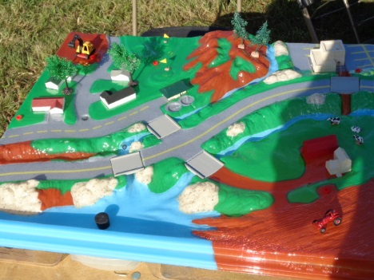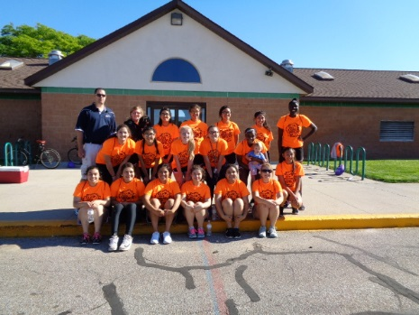

|  |  |  |  |  |  |  |
| --- | --- | --- | --- | --- | --- | --- |
| **Minimum Control Measure: 1** | **Public Education and Outreach** | | | | | |
| **BMP Title: 2** | **Develop Public Service Announcements** | | | | | |
| **Other MCM’s Material Applies To:** | Public Ed. | Public Part. | Illicit Det. | Construction | Post Const. | Houskeep. |
| **X** |  | **X** | **X** |  |  |
| **Suitable For:** | General public – adults, schools, business owners, contractors, developers, builders, consulting engineers, City staff | | | | | |
| **2016 Completed Tasks:** | Distributed Spring Cleanup flyers.  A digital billboard owned by the City runs 24 hour stormwater messages.  **( DETAILED BELOW)** | | | | | |

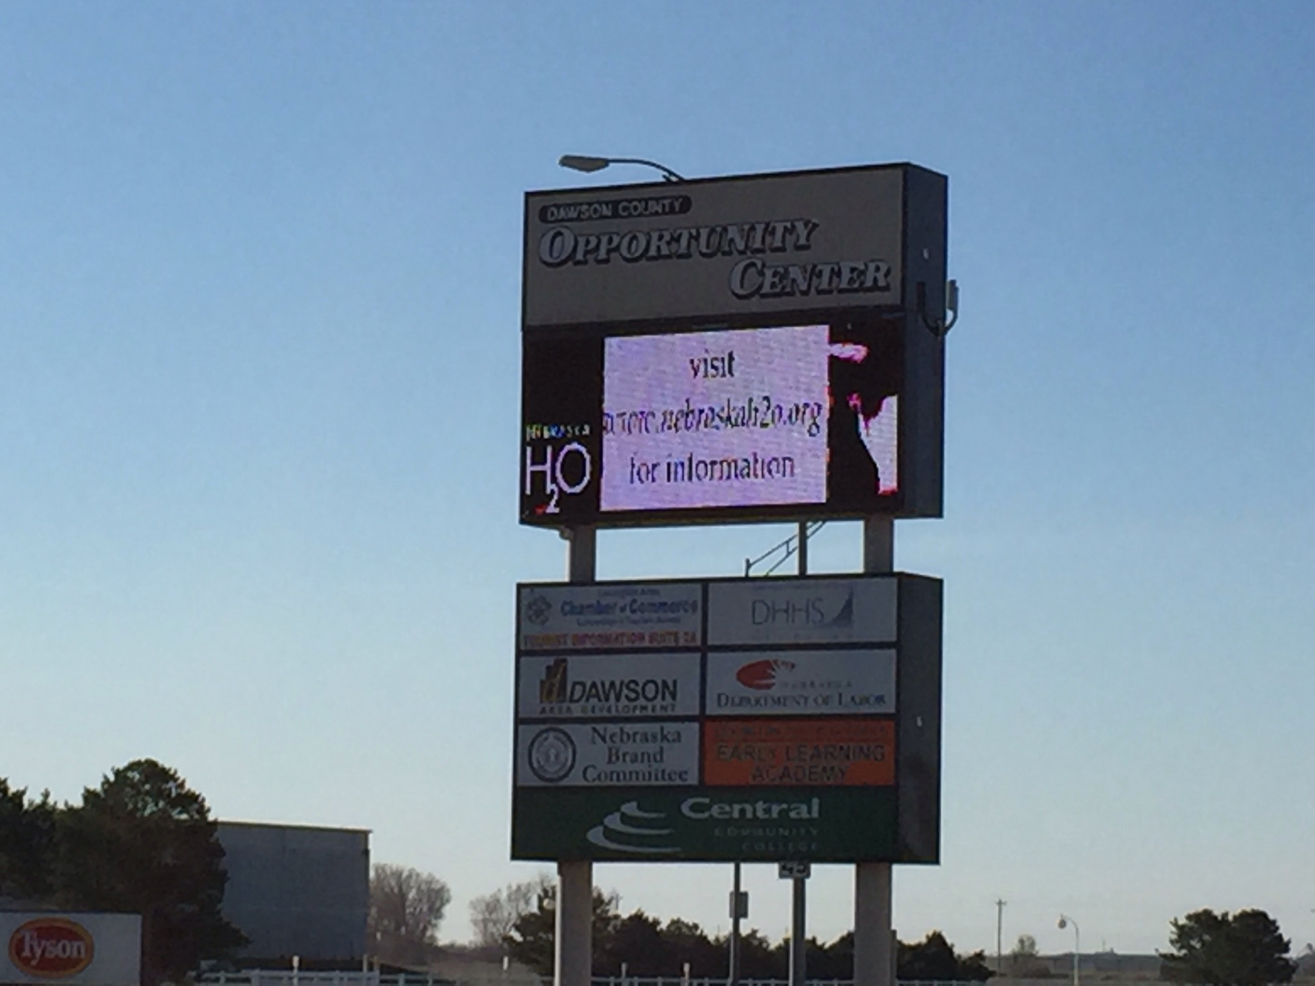

|  |  |  |  |  |  |  |
| --- | --- | --- | --- | --- | --- | --- |
| **Minimum Control Measure: 1** | **Public Education and Outreach** | | | | | |
| **BMP Title: 3** | **Develop Education Materials for Web Site** | | | | | |
| **Other MCM’s Material Applies To:** | Public Ed. | Public Part. | Illicit Det. | Construction | Post Const. | Houskeep. |
| **X** | **X** | **X** | **X** | **X** | **X** |
| **Suitable For:** | General public – adults, schools, business owners, contractors, developers, builders, consulting engineers, City staff | | | | | |
| **2016 Completed Tasks:** | * City of Lexington Storm Water Website updated as needed (2016) * Nebraska H20 Website revised (Cooperative Website)(2015) * Handed out “Stormwater and the Automotive Industry” brochures | | | | | |

|  |
| --- |
| **Storm Water Website:** |
| The City website is a 1 page site with materials directed to all 6 minimum control measures. The site also contains the SWMP and promotes the storm water program as a whole. |
| Nebraska H2O was developed as part of the cooperative and is now maintained by cooperative members. This site serves as a central hub for all Nebraska citizens to obtain information on storm water pollution issues and local contact information. |

|  |  |  |  |  |  |  |
| --- | --- | --- | --- | --- | --- | --- |
| **Minimum Control Measure: 1** | **Public Education and Outreach** | | | | | |
| **BMP Title: 5** | **Develop Call in System of Citizens** | | | | | |
| **Other MCM’s Material Applies To:** | Public Ed. | Public Part. | Illicit Det. | Construction | Post Const. | Houskeep. |
| **X** | **X** | **X** | **X** | **X** |  |
| **Suitable For:** | General public, business owners, contractors, developers, builders, consulting engineers | | | | | |
| **Measurable Goals:** | The Group will provide a call in system to enable the public in member Communities to access educational information related to Storm Water. The system may also be used to receive complaints concerning illicit discharges to the Storm Sewer System and complaints concerning Construction site Storm Water runoff. The system will have the ability to archive calls and maintain records of incoming calls from member communities and track these calls separately by Community. | | | | | |
| **2016 Completed Tasks:** | * Phone number established and promoted with education materials   **( DETAILED BELOW)** | | | | | |

|  |  |  |  |  |
| --- | --- | --- | --- | --- |
| **BMP** | **Goals Achieved** | **Calls Received** | **Effective** | **Appropriate** |
| Stormwater Hotline | Yes | 3 | Yes | Yes |
| **Requested Changes to the BMP.** | | | | |
| No changes are requested at this time. | | | | |

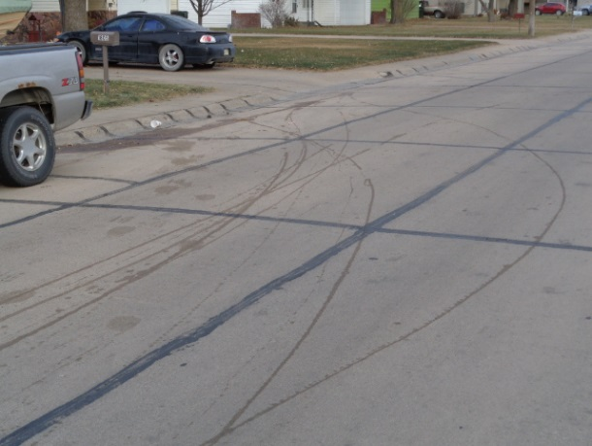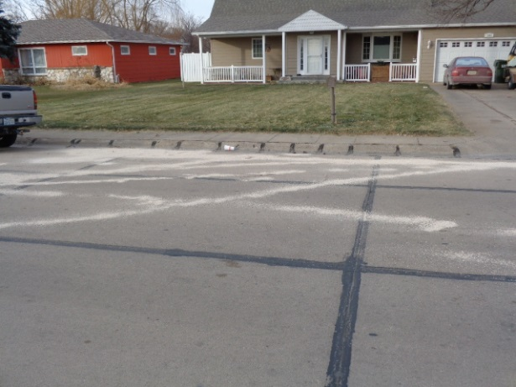

|  |  |  |  |  |  |  |
| --- | --- | --- | --- | --- | --- | --- |
| **Minimum Control Measure: 2** | **Public Involvement and Participation** | | | | | |
| **BMP Title: 1** | **Organize Public Meetings to educate the public on storm water.** | | | | | |
| **Other MCM’s Material Applies To:** | Public Ed. | Public Part. | Illicit Det. | Constr. | Post Const. | Houskeep. |
| **X** | **X** | **X** | **X** |  | **X** |
| **Suitable For:** | General public – adults, business owners, contractors, developers, builders, consulting engineers, City staff | | | | | |
| **2016 Completed Tasks:** | * Created a Stormwater Quality Board. The board will be made up of members of the community and one city council person. The group will meet quarterly to review stormwater plan planning and effectiveness. | | | | | |

**Details:** The City of Lexington focused on Public Participation. Community cleanup programs are in place for ongoing for nine different service groups including Boy and Girl Scouts, Cosmos, Lions, Eagles Clubs, High school football team and different youth Church groups.

|  |  |  |  |  |  |  |
| --- | --- | --- | --- | --- | --- | --- |
| **Minimum Control Measure: 2** | **Public Involvement and Participation** | | | | | |
| **BMP Title: 2** | **Participate/Sponsor Community Clean-Up Event** | | | | | |
| **Other MCM’s Material Applies To:** | Public Ed. | Public Part. | Illicit Det. | Constr. | Post Const. | Houskeep. |
| **X** | **X** | **X** |  |  |  |
| **Suitable For:** | General public – adults, business owners, contractors, developers, builders, consulting engineers, City staff | | | | | |
| **Measurable Goals:** | The Group will provide a summary of the Clean-up events that the Group is involved in. Tracking results of events may help the organizations holding these events in the setting of goals for future events. Through member Communities working together it is hoped the success of various Clean-up events in member Communities and can be used as models for events that can be used for creating similar events in other member Communities in the Group. | | | | | |
| **2016 Completed Tasks:** | * Sponsored Community cleanup programs * Promoted Hazardous cleanup day. * Installed dog cleanup stations * Bioswale constructed at Fieldhouse | | | | | |

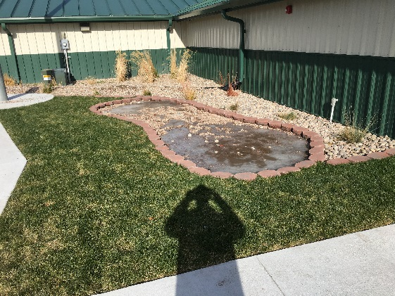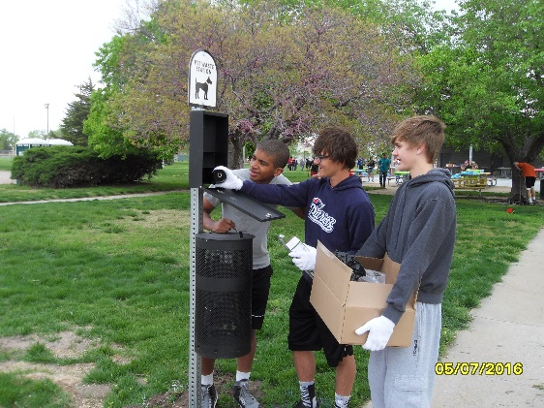

|  |  |  |  |  |  |  |
| --- | --- | --- | --- | --- | --- | --- |
| **Minimum Control Measure: 3** | **Illicit Discharge Detection and Elimination** | | | | | |
| **BMP Title: 1** | **Illicit Discharge Ordinance/Detection Elimination Program** | | | | | |
| **Other MCM’s Material Applies To:** | Public Ed. | Public Part. | Illicit Det. | Constr. | Post Const. | Houskeep. |
| **X** |  | **X** |  |  | **X** |
| **Suitable For:** | City wide improvement | | | | | |

|  |  |  |  |  |  |  |
| --- | --- | --- | --- | --- | --- | --- |
| **Minimum Control Measure: 3** | **Illicit Discharge Detection and Elimination** | | | | | |
| **BMP Title: 2** | **Dry Weather Inspections** | | | | | |
| **Other MCM’s Material Applies To:** | Public Ed. | Public Part. | Illicit Det. | Constr. | Post Const. | Houskeep. |
|  |  | **X** |  |  | **X** |
| **Suitable For:** | City wide improvement | | | | | |

|  |  |  |  |  |  |  |
| --- | --- | --- | --- | --- | --- | --- |
| **Minimum Control Measure: 3** | **Illicit Discharge Detection and Elimination** | | | | | |
| **BMP Title: 3** | **Storm Sewer Mapping** | | | | | |
| **Other MCM’s Material Applies To:** | Public Ed. | Public Part. | Illicit Det. | Constr. | Post Const. | Houskeep. |
|  |  | **X** | **X** |  | **X** |
| **Suitable For:** | City wide improvement | | | | | |
| **Measurable Goals:** | The goal of the Group is to assist member Communities in the updating of their Storm Water System Maps. Completing the maps so they may be used in conjunction with the Illicit Discharge Detection and Elimination Program to track illicit discharges, source of pollutant and areas that Storm Water related complaints are coming from. | | | | | |
| **2016 Completed Tasks:** | * Our maps are updated as needed. | | | | | |

**Summary:** Our GIS department is a continuing effort to update the existing maps as changes are made to system.

|  |  |  |  |  |  |  |
| --- | --- | --- | --- | --- | --- | --- |
| **Minimum Control Measure: 4** | **Construction Site Storm Water Runoff Control** | | | | | |
| **BMP Title: 2** | **Develop Site Inspection and Plan Review Program** | | | | | |
| **Other MCM’s Material Applies To:** | Public Ed. | Public Part. | Illicit Det. | Constr. | Post Const. | Houskeep. |
|  |  |  | **X** | **X** |  |
| **Suitable For:** | Development Community | | | | | |
| **Measurable Goals:** | Havingthe Standard Operating Procedures for Site Inspection and Plan Review developed and a working system in place when the Erosion and Sediment Control Ordinances are adopted by member Communities is the Groups Goal. The Plan Review and Site Inspection are elements that help insure that the rules contained in the ordinance are being followed in the field. | | | | | |
| **2016 Completed Tasks:** | * All projects are reviewed for compliance by the Building Department | | | | | |

|  |  |  |  |  |  |  |
| --- | --- | --- | --- | --- | --- | --- |
| **Minimum Control Measure: 4** | **Construction Site Storm Water Runoff Control** | | | | | |
| **BMP Title: 3** | **Educate Contractors and Development Community** | | | | | |
| **Other MCM’s Material Applies To:** | Public Ed. | Public Part. | Illicit Det. | Constr. | Post Const. | Houskeep. |
|  |  |  | **X** | **X** |  |
| **Suitable For:** | Development Community | | | | | |
| **Measurable Goals:** | The primary goal is to educate as many of the contractors and members of the development community as possible as to how the Storm Water Runoff Program and Erosion and Sediment Control Ordinance will affect them. The feed back from these individuals and groups will be the leading indicator as to the effectiveness of our effort. We should expect a fair amount of feed back negative and positive. | | | | | |
| **2016 Completed Tasks:** | * Educating our contractors by a constant stream of verbal communication. * Handed out “Stormwater and the Construction Industry” brochures | | | | | |

|  |  |  |  |  |  |  |
| --- | --- | --- | --- | --- | --- | --- |
| **Minimum Control Measure: 4** | **Construction Site Storm Water Runoff Control** | | | | | |
| **BMP Title: 4** | **Develop Design Standards** | | | | | |
| **Other MCM’s Material Applies To:** | Public Ed. | Public Part. | Illicit Det. | Constr. | Post Const. | Houskeep. |
|  |  |  | **X** | **X** |  |
| **Suitable For:** | Development Community | | | | | |
| **2016 Completed Tasks:** | * Standard Erosion and Sediment Control Specification for Construction Developed | | | | | |

|  |  |  |  |  |  |  |
| --- | --- | --- | --- | --- | --- | --- |
| **Minimum Control Measure: 5** | **Post Construction Storm Water Management** | | | | | |
| **BMP Title: 2** | **Develop BMP Inspection and Plan Review SOP** | | | | | |
| **Other MCM’s Material Applies To:** | Public Ed. | Public Part. | Illicit Det. | Constr. | Post Const. | Houskeep. |
|  |  |  | **X** | **X** |  |
| **Suitable For:** | Development Community | | | | | |
| **2016 Completed Tasks:** | **The City of Lexington has in place the inspection and plan review process. These tasks will be performed by the Building Department.** | | | | | |

|  |  |  |  |  |  |  |
| --- | --- | --- | --- | --- | --- | --- |
| **Minimum Control Measure: 5** | **Post Construction Storm Water Management** | | | | | |
| **BMP Title: 3** | **Develop Education Materials for Post Construction BMPs** | | | | | |
| **Other MCM’s Material Applies To:** | Public Ed. | Public Part. | Illicit Det. | Constr. | Post Const. | Houskeep. |
|  |  |  | **X** | **X** |  |
| **Suitable For:** | Development Community | | | | | |
| **Measurable Goals:** | The Educational materials will be made available to the Development Community. The Development Community’s participation in the design and development of BMPs is critical for the goal of the reduction or elimination of Storm Water Runoff sediment or pollutants for Post Construction to the maximum extent practicable. | | | | | |
| **2016 Completed Tasks:** | * These educational materials are available. | | | | | |

|  |  |  |  |  |  |  |
| --- | --- | --- | --- | --- | --- | --- |
| **Minimum Control Measure: 6** | **Pollution Prevention / Good Housekeeping** | | | | | |
| **BMP Title: 1** | **Develop Training Materials for City Employees** | | | | | |
| **Other MCM’s Material Applies To:** | Public Ed. | Public Part. | Illicit Det. | Constr. | Post Const. | Houskeep. |
|  |  |  |  |  | **X** |
| **Suitable For:** | City Employees: Utilities, Public Works, Park and Recreation, Sanitation, Maintenance, Public Safety | | | | | |
| **Measurable Goals:** | Develop attention getting training materials for City Employees that will generate interest in Storm Water related issues. Increase Employee awareness of how their actions at work and at home can affect Storm Water Runoff water quality. | | | | | |
| **2016 Completed Tasks:** | * Municipal Storm Water Pollution Prevention Video * MS4s Rain Check Training Video | | | | | |

|  |  |  |  |  |  |  |
| --- | --- | --- | --- | --- | --- | --- |
| **Minimum Control Measure: 6** | **Pollution Prevention / Good Housekeeping** | | | | | |
| **BMP Title: 3** | **Evaluate Municipal Operations** | | | | | |
| **Other MCM’s Material Applies To:** | Public Ed. | Public Part. | Illicit Det. | Constr. | Post Const. | Houskeep. |
|  |  |  |  |  | **X** |
| **Suitable For:** | City Employees: Utilities, Public Works, Park and Recreation, Sanitation, Maintenance, Public Safety | | | | | |
| **Measurable Goals:** | The Standard Operating procedures will provide guidelines to member Communities on how they can evaluate their municipal operations and maintenance activities related to Storm Water Runoff. The Standard Operating Procedures provide a uniform method for performing the evaluations. The Group will ask member Communities to return completed evaluations to them to be summarized and submitted to the Group for comment. | | | | | |
| **2016 Completed Tasks:** | * City Service Facility Evaluated * North Park Facilities Evaluated (4 parks) * South Park Facilities Evaluated (2 parks) * Lexington Cemeteries Evaluated * Installed Salt/Sand storage building at City Service Building * Total of 3,130 miles of streets swept during 2016 reporting year | | | | | |

