

**Nebraska Department of Environmental Quality**

**Authorization to Discharge Under the NPDES Storm Water Phase II Municipal Separate Storm Sewer System (MS4) General Permit**

**Authorization No. NE 300003**

**City of Lexington**

**Phase II MS4 Annual Report for Permit Year Five**

**For Reporting Period: 01/01/13 through 12/31/13**

**Executive Summary**

In August 2005, the City of Lexington submitted the Notice of Intent for coverage under the NDEQ General Permit for Phase II Municipal Separate Storm Sewer Systems (MS4) Discharges for Small Cities within the State of Nebraska. Lexington also submitted portions of the Storm Water Management Program (SWMP) as required by the permit. The SWMP identifies the MCMs and the BMPs, measurable goals, and implementation schedules for the MCMs. The permit requires the submission of an Annual Report to the NDEQ for each permit year within sixty (90) days after the anniversary date of the permit coverage which commenced on January 1, 2006 for Lexington. As required by the permit, Lexington evaluated the implementation of the BMPs for each MCM and assessed the overall compliance with the MCMs.

This annual compliance evaluation report fulfills the MS4 permit requirement to assess compliance with permit conditions, appropriateness of Best Management Practices (BMPs), and progress towards statutory goals of the permit and Measurable Goals established for each Minimum Control Measure (MCM). The attached report presents the results of this assessment and brief summaries representing implemented activities as required by the Nebraska Department of Environmental Quality (NDEQ) Permit NER300000.

The evaluation shows that Lexington is in compliance with the SWMP. Further this evaluation indicates that Lexington excelled in many of the Measurable Goals and has progressed exceptionally by accelerating the implementation of several BMPs ahead of the schedule and has performed additional BMPs not stated in the SWMP.

# CERTIFICATION STATEMENT AND SIGNATURE

*The Responsible Authority listed in Section 1.B. of the annual report form must sign the following the certification statement:* I certify under penalty of law that this document and all attachments were prepared under my direction or supervision in accordance with a system designed to assure that qualified personnel properly gathered and evaluated the information submitted. Based upon my inquiry of the person or persons who manage the system, or those persons directly responsible for gathering the information, the information submitted is, to the best of my knowledge and belief, true, accurate and complete. I am aware that there are significant penalties for submitting false information, including the possibility of fine and imprisonment for knowing violations.

|  |
| --- |
| Name of Phase II MS4 Responsible Authority ( Type or print):  Bill Brecks |
| Signature: Date: |

**Permittee Information**

Permittee: City of Lexington

Contact Person: Joe Pepplitsch, City Manager

Bill Brecks, Storm Water Program Manager

Mailing Address: City of Lexington, 406 E. 7th Street, Lexington, NE, 68850

Contact Phone Number: (308) 324-2341

Authorization Number: NER 300003

Authorization Date: January 1, 2006

Annual Report Due Date: April 1, 2013

Reporting Period: 1/1/13-12/31/13

**Status of Compliance with Permit Conditions**

The Permittee is in compliance with the Phase II MS4 General Permit conditions. The Permittee has developed a comprehensive SWMP according to the requirements of the permit including BMPs, Measurable Goals, and implementation schedules for each of the seven MCMs. For this Annual Report, the Permittee has evaluated compliance in regards to the SWMP implementation schedule and the Measurable Goals. The Permittee is in compliance with these previously submitted implementation schedules. To the best knowledge of the Permittee, all required documentation and records are currently accounted for and stored in a centralized records database.

Progress towards Achieving the Statutory Goal of Reducing the Discharge of Pollutants to the waters of the State of US.

Implementation of BMPs consistent with the provisions of the SWMP required pursuant to 40 Code of Federal Regulations (CFR) 122.33 and 122.34 constitutes compliance with the standard of reducing pollutants to the MEP.

The Permittee has developed a comprehensive SWMP according to the requirements of the permit including BMPs, Measurable Goals, and implementation schedules for each of the six MCMs. For this Annual Report, the Permittee has evaluated its compliance in regards to the SWMP implementation schedule and has assessed the appropriateness of each BMP as described in Section 3. The Permittee has made progress towards achieving the statutory goal of reducing the discharge of pollutants to the MEP. To the best knowledge of the Permittee, all required documentation and records are currently accounted for and stored in a centralized records database.

Description and Schedule for Implementation of any Additional BMPs or Monitoring that may be Necessary to Ensure Compliance with any Applicable Total Maximum Daily Load (TMDL)

The City of Lexington does not currently discharge to any stream segments that have approved TMDLs during this reporting period.

Notice of Reliance on another Government Entity to Satisfy some of the Permit Obligations (if Applicable) and a Copy of the Written Agreement with that Entity

The City of Lexington does not rely on another government entity for compliance with any part of this permit. The City of Lexington is actively involved in the Nebraska Storm Water Cooperative (NSWC) and many public education items are based off of the Nebraska H2O public education program.

**Section 1:**

***Progress Toward Achieving Measurable Goals***

|  |  |  |  |  |  |  |
| --- | --- | --- | --- | --- | --- | --- |
| **Minimum Control Measure: 1** | **Public Education and Outreach** | | | | | |
| **BMP Title: 1** | **Develop and Distribute Educational Materials** | | | | | |
| **Other MCM’s Material Applies To:** | Public Ed. | Public Part. | Illicit Det. | Constr. | Post Const. | Houskeep. |
| **X** | **X** | **X** | **X** |  | **X** |
| **Suitable For:** | General public – adults, schools (5th-12th), business owners, contractors, developers, builders, consulting engineers, City staff | | | | | |
| **Measurable Goals:** | Media campaigns will be developed and implemented by the Group. Educational Materials will be distributed to member Communities under the direction of the Group. Evaluation of materials and media campaigns by tracking feedback and public participation in the campaigns will be done by the Group.. | | | | | |
| **2013 Completed Tasks:** | * Two printed brochures with various topics were distributed. * Nebraska H2O Commercial Aired * Bi-Monthly program advertisement in “Lexington City Happenings” citizen newsletter * Participation in the Outdoor Expo & Childrens Water Festival where we educated students and adults about storm water pollution * Presentations in the Lexington Public Schools for 3rd, 4th, 6th and 7th grade students   **( DETAILED BELOW)** | | | | | |

|  |
| --- |
| **Brochures/Flyers** |
| *Nebraska H2O “Our Water… Our Responsibility.”*  **Printed:600 Distributed: 600** |
| **Other Printed Materials:** |
| *City Happenings Newsletter “Storm Water Education Article”*  **Distributed: 1500 e-mail recipients plus printed bi-monthly** |
| **TV and Radio:** |
| *TV Commercial; Produced by Nebraska H2O and given to communities to run on local stations.*  **The cities of Lexington, Kearney, and Grand Island ran on NTV.** |

**Summary:**

|  |  |  |  |  |
| --- | --- | --- | --- | --- |
| **BMP** | **Goals**  **Achieved** | **Effective** | **Appropriate** |  |
| Printed Materials | Yes | Yes | Yes |  |
| TV and Radio | Yes | Yes | Yes |  |
|  |  |  |  |  |
| **Requested Changes to BMP:** | | | | |
| No changes are requested at this time. | | | | |

**Additional Comments:**

In 2013, we continued to try and expand our education to the youth of the City. Through the presentations and the message of clean water in printed materials we feel using the kids as a conduit to the adults of the community is a positive. We were able to get our message out to kids ranging from 3rd to 7th grade through presentations. We were also able to reach high school aged kids through other programs. Those programs allow us to do more one-on-one teaching.

New this year we began sponsoring and providing volunteers for different runs in the city. The 4th of July and Mascot March funs runs provided us an audience for stormwater awareness allowing us to get our message out to citizens of all ages.

4th of July 5k

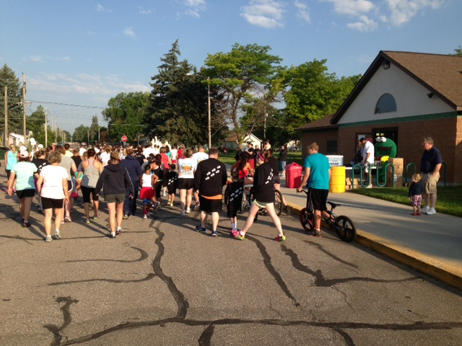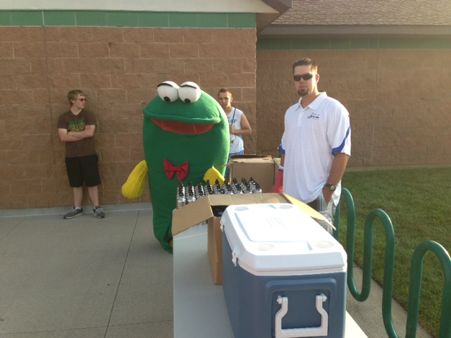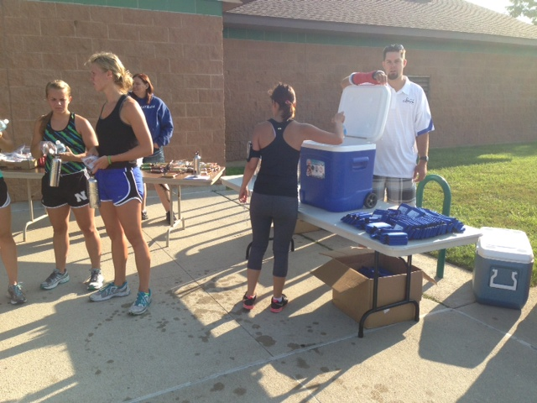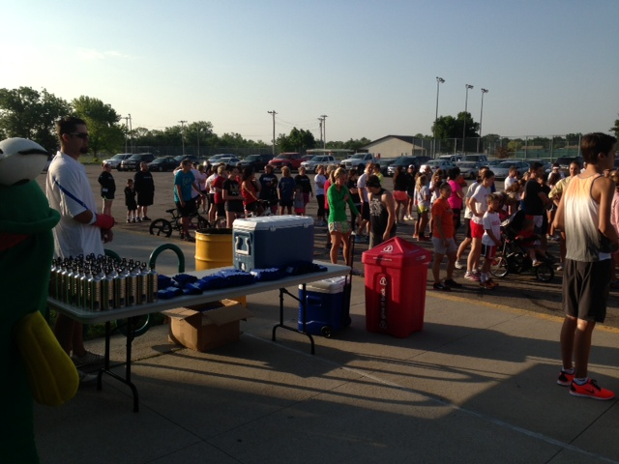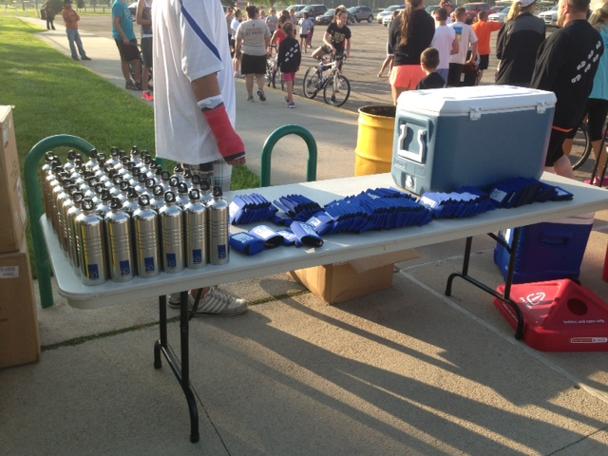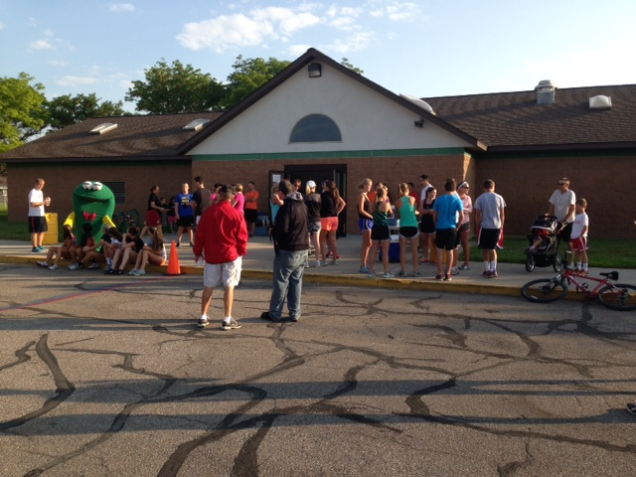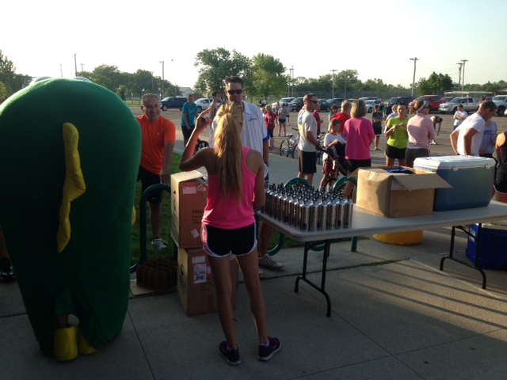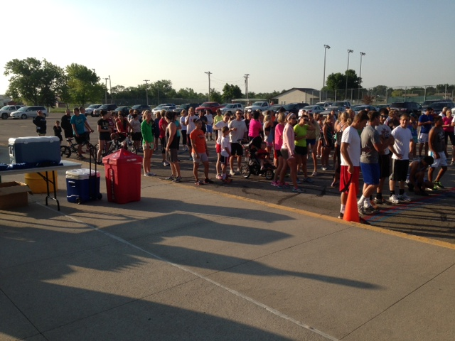

Mascot March

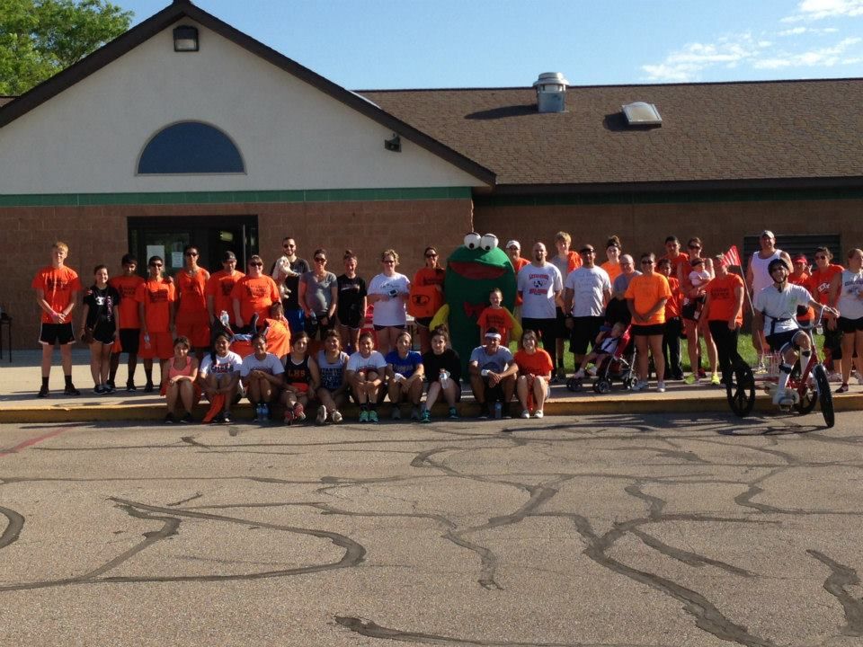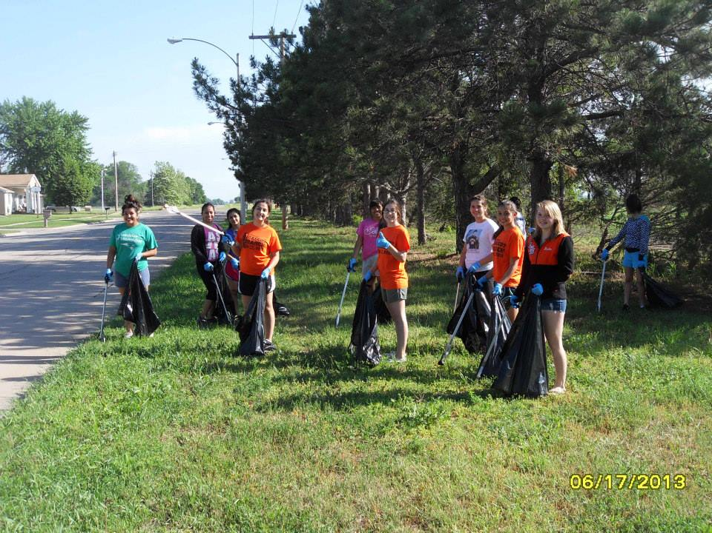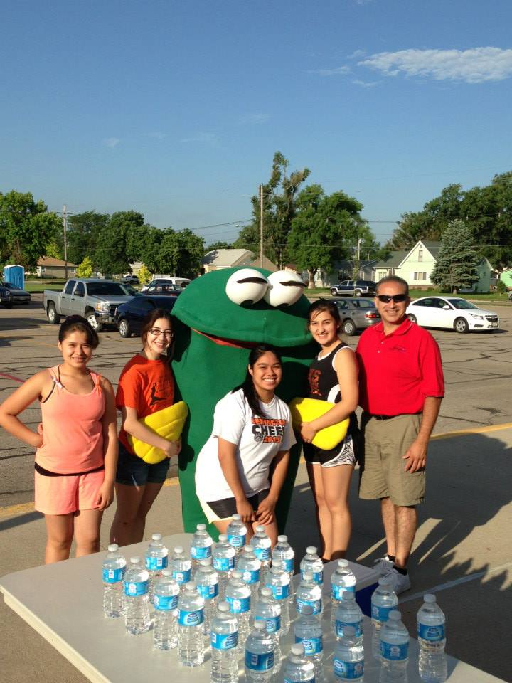

Classroom attendance for education.





|  |  |  |  |  |  |  |
| --- | --- | --- | --- | --- | --- | --- |
| **Minimum Control Measure: 1** | **Public Education and Outreach** | | | | | |
| **BMP Title: 2** | **Develop Public Service Announcements** | | | | | |
| **Other MCM’s Material Applies To:** | Public Ed. | Public Part. | Illicit Det. | Construction | Post Const. | Houskeep. |
| **X** |  | **X** | **X** |  |  |
| **Suitable For:** | General public – adults, schools, business owners, contractors, developers, builders, consulting engineers, City staff | | | | | |
| **Measurable Goals:** | The Group will be evaluating each of the Public Service Announcements it distributes by the response and feedback received from the public concerning the Announcement. The Group will be responsible for evaluating the effectiveness of each of the Public Service Announcements that are distributed. The Group will then be responsible for implementing the recommended changes in the public service announcements. | | | | | |
| **2013 Completed Tasks:** | Distributed Spring Cleanup flyers and Nebraska H2O.  A digital billboard owned by the City runs 24 hour stormwater messages  **( DETAILED BELOW)** | | | | | |

|  |
| --- |
| **Printed PSA:** |
| Spring Cleanup and Nebraska H2O were developed and distributed  **Distributed to list above.** |

|  |  |  |  |  |
| --- | --- | --- | --- | --- |
| **BMP** | **Goal Achieved** | **PSA’s in place** | **Effective** | **Appropriate** |
| Printed | Yes | 2 | Yes | Yes |
| **Requested Changes to the BMP:** |  |  |  |  |
| No changes are requested to the BMP at this time. | | | | |

|  |  |  |  |  |  |  |
| --- | --- | --- | --- | --- | --- | --- |
| **Minimum Control Measure: 1** | **Public Education and Outreach** | | | | | |
| **BMP Title: 3** | **Develop Education Materials for Web Site** | | | | | |
| **Other MCM’s Material Applies To:** | Public Ed. | Public Part. | Illicit Det. | Construction | Post Const. | Houskeep. |
| **X** | **X** | **X** | **X** | **X** | **X** |
| **Suitable For:** | General public – adults, schools, business owners, contractors, developers, builders, consulting engineers, City staff | | | | | |
| **Measurable Goals:** | In the public area of the Website the number of hits will be recorded on the Website. As the Plan evolves the Group will use the site to implement more and more programs associated with the various programs associated with the plan. The Website will be constantly evolving as the elements of the SWMP are implemented. The use of Data Pages on the site that can be used to access Data Base programs will be a primary use of the site for member Communities. The Data Base programs will be used to track most aspects of the programs created by the Plan. The Data Base programs will also be used for the development of annual reports for the Group and for member Communities. | | | | | |
| **2013 Completed Tasks:** | * City of Lexington Storm Water Website updated as needed (2013) * Nebraska H20 Website revised (Cooperative Website)(2013)   **( DETAILED BELOW)** | | | | | |

**Additional Comments:**

Each site is evaluated and updated as needed throughout the year. Both sites will continue to be a part of the City of Lexington storm water program. Our cooperative with other MS4’s is currently developing a new website with bulk e-mail functions to reach contractors, developers and teachers.

|  |  |  |  |  |  |  |
| --- | --- | --- | --- | --- | --- | --- |
| **Minimum Control Measure: 1** | **Public Education and Outreach** | | | | | |
| **BMP Title: 5** | **Develop Call in System of Citizens** | | | | | |
| **Other MCM’s Material Applies To:** | Public Ed. | Public Part. | Illicit Det. | Construction | Post Const. | Houskeep. |
| **X** | **X** | **X** | **X** | **X** |  |
| **Suitable For:** | General public, business owners, contractors, developers, builders, consulting engineers | | | | | |
| **Measurable Goals:** | The Group will provide a call in system to enable the public in member Communities to access educational information related to Storm Water. The system may also be used to receive complaints concerning illicit discharges to the Storm Sewer System and complaints concerning Construction site Storm Water runoff. The system will have the ability to archive calls and maintain records of incoming calls from member communities and track these calls separately by Community. | | | | | |
| **2013 Completed Tasks:** | * Phone number established and promoted with education materials   **( DETAILED BELOW)** | | | | | |

|  |  |  |  |  |
| --- | --- | --- | --- | --- |
| **Permit YearBMP** | **Goals Achieved** | **Calls Received** | **Effective** | **Appropriate** |
| Stormwater Hotline | Yes | 6 | Yes | Yes |
| **Requested Changes to the BMP.** | | | | |
| No changes are requested at this time. | | | | |

|  |  |  |  |  |  |  |
| --- | --- | --- | --- | --- | --- | --- |
| **Minimum Control Measure: 2** | **Public Involvement and Participation** | | | | | |
| **BMP Title: 1** | **Organize Public Meetings to educate the public on storm water.** | | | | | |
| **Other MCM’s Material Applies To:** | Public Ed. | Public Part. | Illicit Det. | Constr. | Post Const. | Houskeep. |
| **X** | **X** | **X** | **X** |  | **X** |
| **Suitable For:** | General public – adults, business owners, contractors, developers, builders, consulting engineers, City staff | | | | | |
| **Measurable Goals:** | The Group and meeting presenters will track attendance numbers at meetings. | | | | | |
| **2013 Completed Tasks:** | * Presented at the Meeting on NPDES.   **( DETAILED BELOW)** | | | | | |

|  |  |
| --- | --- |
| **Public Meetings Overview:** | **Attendance:** |
| Nebraska Stormwater Cooperative meetings | No numbers available |

**Details:** The City of Lexington focused on Public Participation. Community cleanup programs are in place for ongoing for nine different service groups including Boy and Girl Scouts, Cosmos, Lions, Eagles Clubs and different youth Church groups.

**Summary:**

|  |  |  |  |  |
| --- | --- | --- | --- | --- |
| **BMP** | **Goals Achieved** | **Events Held** | **Effective** | **Appropriate** |
| Public Meetings | Yes | 8 | Yes | Yes |
| **Request to change the BMP.** | | | | |
| No changes are requested at this time. | | | | |

|  |  |  |  |  |  |  |
| --- | --- | --- | --- | --- | --- | --- |
| **Minimum Control Measure: 2** | **Public Involvement and Participation** | | | | | |
| **BMP Title: 2** | **Participate/Sponsor Community Clean-Up Event** | | | | | |
| **Other MCM’s Material Applies To:** | Public Ed. | Public Part. | Illicit Det. | Constr. | Post Const. | Houskeep. |
| **X** | **X** | **X** |  |  |  |
| **Suitable For:** | General public – adults, business owners, contractors, developers, builders, consulting engineers, City staff | | | | | |
| **Measurable Goals:** | The Group will provide a summary of the Clean-up events that the Group is involved in. Tracking results of events may help the organizations holding these events in the setting of goals for future events. Through member Communities working together it is hoped the success of various Clean-up events in member Communities and can be used as models for events that can be used for creating similar events in other member Communities in the Group. | | | | | |
| **2013 Completed Tasks:** | * Sponsored Community cleanup programs * Scrap Tire Drop-off Day * Earth Day Downtown Cleanup   **( DETAILED BELOW)** | | | | | |

**Details:** The City of Lexington Community Service Department has garbage containers on site that allow citizens a way to dump waste without having to pay for the disposal fees. This program greatly reduces the amount of waste that may end up in our rivers and lakes if the program was not available.

|  |  |  |  |  |
| --- | --- | --- | --- | --- |
| **BMP** | **Goals Achieved** | **Events Held** | **Effective** | **Appropriate** |
| Community Clean-up Event | Yes | 14 | Yes | Yes |
| **Requested Changes to BMP:** |  |  |  |  |
| No changes are requested at this time. | | | | |

|  |  |  |  |  |  |  |
| --- | --- | --- | --- | --- | --- | --- |
| **Minimum Control Measure: 2** | **Illicit Discharge Detection and Elimination** | | | | | |
| **BMP Title: 2** | **Dry Weather Inspections** | | | | | |
| **Other MCM’s Material Applies To:** | Public Ed. | Public Part. | Illicit Det. | Constr. | Post Const. | Houskeep. |
|  |  | **X** |  |  | **X** |
| **Suitable For:** | City wide improvement | | | | | |
| **Measurable Goals:** | By using a centralized data base and Standard Operating Procedures for member communities the Group will be able to compile the data collected during Dry Weather Inspections of Storm Water Outfalls. The compiled data will then be analyzed for each member community showing trends and identifying problem areas. The data can also be used and analyzed for the Group showing overall trends and comparing the data from member Communities. | | | | | |

**Detailed Summary:** Permit year two was dedicated to the program development of the BMP. The tracking and record keeping was a top priority when considering the future needs of this program. The City of Lexington researched many different types of record keeping software for this program and has determined that Asist storm water software will complete all needed tasks. This software will was purchased and is ready for dry weather investigations.

|  |  |  |  |
| --- | --- | --- | --- |
| **BMP** | **Goal Achieved** | **Effective** | **Appropriate** |
| Dry weather investigation program | Yes | Yes | Yes |
| **Requested Changes to the BMP.** | | | |
| No changes are requested at this time. | | | |

|  |  |  |  |  |  |  |
| --- | --- | --- | --- | --- | --- | --- |
| **Minimum Control Measure: 3** | **Illicit Discharge Detection and Elimination** | | | | | |
| **BMP Title: 3** | **Storm Sewer Mapping** | | | | | |
| **Other MCM’s Material Applies To:** | Public Ed. | Public Part. | Illicit Det. | Constr. | Post Const. | Houskeep. |
|  |  | **X** | **X** |  | **X** |
| **Suitable For:** | City wide improvement | | | | | |
| **Measurable Goals:** | The goal of the Group is to assist member Communities in the updating of their Storm Water System Maps. Completing the maps so they may be used in conjunction with the Illicit Discharge Detection and Elimination Program to track illicit discharges, source of pollutant and areas that Storm Water related complaints are coming from. | | | | | |
| **2013 Completed Tasks:** | * Our maps are updated as needed.   **( DETAILED BELOW)** | | | | | |

|  |  |  |  |
| --- | --- | --- | --- |
| **BMP** | **Goal Achieved** | **Effective** | **Appropriate** |
| Mapping | Yes | Yes | Yes |
| **Requested Changes to the BMP:** | | | |
| No changes are requested at this time. | | | |

**Summary:** Our GIS department is a continuing effort to update the existing maps as changes are made to system.

|  |  |  |  |  |  |  |
| --- | --- | --- | --- | --- | --- | --- |
| **Minimum Control Measure: 4** | **Construction Site Storm Water Runoff Control** | | | | | |
| **BMP Title: 1** | **Develop a Erosion and Sediment Control Ordinance** | | | | | |
| **Other MCM’s Material Applies To:** | Public Ed. | Public Part. | Illicit Det. | Constr. | Post Const. | Houskeep. |
|  |  | **X** | **X** | **X** |  |
| **Suitable For:** | Development Community | | | | | |
| **Measurable Goals:** | Developing the Ordinance and Standard Operating Procedures for the Program that may be adopted into member Communities City Codes will be the first step in implementing the Program. The Group will provide support in any way possible to member Communities in this process and document the progress and or obstacles it finds during the approval process in member Communities. | | | | | |
| **2013 Completed Tasks:** | * Ordinance #2291 signed   **( DETAILED BELOW)** | | | | | |

|  |  |  |  |
| --- | --- | --- | --- |
| **BMP** | **Goal Achieved** | **Effective** | **Appropriate** |
| Ordinance | Yes | Yes | Yes |
| **Requested Changes to the BMP:** | | | |
| No changes are requested at this time. | | | |

|  |  |  |  |  |  |  |
| --- | --- | --- | --- | --- | --- | --- |
| **Minimum Control Measure: 4** | **Construction Site Storm Water Runoff Control** | | | | | |
| **BMP Title: 2** | **Develop Site Inspection and Plan Review Program** | | | | | |
| **Other MCM’s Material Applies To:** | Public Ed. | Public Part. | Illicit Det. | Constr. | Post Const. | Houskeep. |
|  |  |  | **X** | **X** |  |
| **Suitable For:** | Development Community | | | | | |
| **Measurable Goals:** | Havingthe Standard Operating Procedures for Site Inspection and Plan Review developed and a working system in place when the Erosion and Sediment Control Ordinances are adopted by member Communities is the Groups Goal. The Plan Review and Site Inspection are elements that help insure that the rules contained in the ordinance are being followed in the field. | | | | | |
| **2013 Completed Tasks:** | * 10 projects reviewed for compliance   **( DETAILED BELOW)** | | | | | |

|  |  |  |  |  |
| --- | --- | --- | --- | --- |
| **BMP** | **Goal Achieved** | **Plans Reviewed** | **Effective** | **Appropriate** |
| Ordinance | Yes | 25 | Yes | Yes |
| **Requested Changes to the BMP:** | | | | |
| No changes are requested at this time. | | | | |

|  |  |  |  |  |  |  |
| --- | --- | --- | --- | --- | --- | --- |
| **Minimum Control Measure: 4** | **Construction Site Storm Water Runoff Control** | | | | | |
| **BMP Title: 3** | **Educate Contractors and Development Community** | | | | | |
| **Other MCM’s Material Applies To:** | Public Ed. | Public Part. | Illicit Det. | Constr. | Post Const. | Houskeep. |
|  |  |  | **X** | **X** |  |
| **Suitable For:** | Development Community | | | | | |
| **Measurable Goals:** | The primary goal is to educate as many of the contractors and members of the development community as possible as to how the Storm Water Runoff Program and Erosion and Sediment Control Ordinance will affect them. The feed back from these individuals and groups will be the leading indicator as to the effectiveness of our effort. We should expect a fair amount of feed back negative and positive. | | | | | |
| **2013 Completed Tasks:** | * Educating our contractors by a constant stream of verbal communication. | | | | | |

**Additional Comments:** Training courses developed in conjunction with NDOR will be them main source of training provided to the area development community. At years end a quarterly newsletter was developed and will continue to by utilized.

|  |  |  |  |  |
| --- | --- | --- | --- | --- |
| **BMP** | **Goal Achieved** | **Individuals at meetings** | **Effective** | **Appropriate** |
| Education for development | Yes | Field Meetings no numbers | Yes | Yes |
| **Requested Changes to the BMP:** | | | | |
| No changes are requested at this time. | | | | |

|  |  |  |  |  |  |  |
| --- | --- | --- | --- | --- | --- | --- |
| **Minimum Control Measure: 4** | **Construction Site Storm Water Runoff Control** | | | | | |
| **BMP Title: 4** | **Develop Design Standards** | | | | | |
| **Other MCM’s Material Applies To:** | Public Ed. | Public Part. | Illicit Det. | Constr. | Post Const. | Houskeep. |
|  |  |  | **X** | **X** |  |
| **Suitable For:** | Development Community | | | | | |
| **Measurable Goals:** | The goal is to include Design Standards as part of the Construction Site Storm Water Runoff Controls Program to provide information and guidance for the design of effective runoff controls. The Group intends to have these Design Standards available to those affected by them as early as possible in the process so they have time to adjust to them. By having the representatives of the people affected by the Design Standards involved in the development of those standards this will expedite the education process about the new Design Standards. The success of the Construction Site Storm Water Runoff Control Program depends on the people involved following the Standards to construct and maintain adequate structural and non-structural control elements to reduce and eliminate sediments and pollutants in Storm Water Runoff from Construction Sites. | | | | | |
| **2013 Completed Tasks:** | * Standard Erosion and Sediment Control Specification for Construction Developed   **( DETAILED BELOW)** | | | | | |

**Summary:**

Standard Construction Specifications were developed to include in all City of Lexington owned projects. These standard specifications are not a requirement for private construction projects. All contractors that work on city projects are required to follow the guidelines provided in the individual project SWPPP’S.

|  |  |  |  |
| --- | --- | --- | --- |
| **BMP** | **Goal Achieved** | **Effective** | **Appropriate** |
| Design Standards | Yes | Yes | Yes |
| **Requested Changes to the BMP:** | | | |
|  | | | |

**Additional Comments:** The process of reviewing other manuals from around the country has begun and we will continue to search out the proper standards for our area can be met.

|  |  |  |  |  |  |  |
| --- | --- | --- | --- | --- | --- | --- |
| **Minimum Control Measure: 5** | **Post Construction Storm Water Management** | | | | | |
| **BMP Title: 1** | **Develop Post-Construction Ordinance** | | | | | |
| **Other MCM’s Material Applies To:** | Public Ed. | Public Part. | Illicit Det. | Constr. | Post Const. | Houskeep. |
|  |  |  | **X** | **X** |  |
| **Suitable For:** | Development Community | | | | | |
| **Measurable Goals:** | The Ordinance is intended to identify the responsible parties for the maintenance and up keep of Storm Water Controls in New Development and Redevelopment. Keeping controls in good repair and working correctly is a primary goal of the program. | | | | | |
| **2013 Completed Tasks:** | * Ordinance #2291 approved   **( DETAILED BELOW)** | | | | | |

**Summary:**

|  |  |  |  |
| --- | --- | --- | --- |
| **BMP** | **Goal Achieved** | **Effective** | **Appropriate** |
| Post Construction Ordinance Draft | Yes | NA | Yes |
| **Requested Changes to the BMP:** | | | |
| No changes are requested at this time. | | | |

|  |  |  |  |  |  |  |
| --- | --- | --- | --- | --- | --- | --- |
| **Minimum Control Measure: 5** | **Post Construction Storm Water Management** | | | | | |
| **BMP Title: 2** | **Develop BMP Inspection and Plan Review SOP** | | | | | |
| **Other MCM’s Material Applies To:** | Public Ed. | Public Part. | Illicit Det. | Constr. | Post Const. | Houskeep. |
|  |  |  | **X** | **X** |  |
| **Suitable For:** | Development Community | | | | | |
| **Measurable Goals:** | The Inspection and Plan review process is how the Communities know that the provisions of the Post Construction Ordinance are being followed. The Standard Operating Procedures will act as Guidelines for the Inspection and Plan Review process. By Developing the Ordinance and the Standard Operating Procedures as a Group the Ordinance and Procedures will be virtually the same in member Communities this uniformity may save confusion among the Development Community members that have ties to other member Communities. | | | | | |
| **2013 Completed Tasks:** | **The City of Lexington has in place the inspection and plan review process. These tasks will be performed by the Building Department.** | | | | | |

|  |  |  |  |
| --- | --- | --- | --- |
| **BMP** | **Goal Achieved** | **Effective** | **Appropriate** |
| Post Construction Inspection/Plan Review | Yes | Yes | Yes |
| **Requested Changes to the BMP:** | | | |
| No changes are requested at this time. | | | |

|  |  |  |  |  |  |  |
| --- | --- | --- | --- | --- | --- | --- |
| **Minimum Control Measure: 5** | **Post Construction Storm Water Management** | | | | | |
| **BMP Title: 3** | **Develop Education Materials for Post Construction BMPs** | | | | | |
| **Other MCM’s Material Applies To:** | Public Ed. | Public Part. | Illicit Det. | Constr. | Post Const. | Houskeep. |
|  |  |  | **X** | **X** |  |
| **Suitable For:** | Development Community | | | | | |
| **Measurable Goals:** | The Educational materials will be made available to the Development Community. The Development Community’s participation in the design and development of BMPs is critical for the goal of the reduction or elimination of Storm Water Runoff sediment or pollutants for Post Construction to the maximum extent practicable. | | | | | |
| **2013 Completed Tasks:** | * These educational materials are available.   **( DETAILED BELOW)** | | | | | |

|  |  |  |  |
| --- | --- | --- | --- |
| **BMP** | **Goal Achieved** | **Effective** | **Appropriate** |
| Post Construction Education Materials | Yes | Yes | Yes |
| **Requested Changes to the BMP:** | | | |
| No changes are requested at this time. | | | |

|  |  |  |  |  |  |  |
| --- | --- | --- | --- | --- | --- | --- |
| **Minimum Control Measure: 6** | **Pollution Prevention / Good Housekeeping** | | | | | |
| **BMP Title: 1** | **Develop Training Materials for City Employees** | | | | | |
| **Other MCM’s Material Applies To:** | Public Ed. | Public Part. | Illicit Det. | Constr. | Post Const. | Houskeep. |
|  |  |  |  |  | **X** |
| **Suitable For:** | City Employees: Utilities, Public Works, Park and Recreation, Sanitation, Maintenance, Public Safety | | | | | |
| **Measurable Goals:** | Develop attention getting training materials for City Employees that will generate interest in Storm Water related issues. Increase Employee awareness of how their actions at work and at home can affect Storm Water Runoff water quality. | | | | | |
| **2013 Completed Tasks:** | * Municipal Storm Water Pollution Prevention Video   **( DETAILED BELOW)** | | | | | |

**Additional Comments:** Training will be developed in many forms and will continue.

|  |  |  |  |  |
| --- | --- | --- | --- | --- |
| **BMP** | **Goal Achieved** | **Printed**  **Matl.** | **Effective** | **Appropriate** |
| Education for employees | Yes | All employees identified as targets traained | Yes | Yes |
| **Requested Changes to the BMP:** | | | | |
| No changes are requested at this time. | | | | |

|  |  |  |  |  |  |  |
| --- | --- | --- | --- | --- | --- | --- |
| **Minimum Control Measure: 6** | **Pollution Prevention / Good Housekeeping** | | | | | |
| **BMP Title: 2** | **Evaluate Street Cleaning Program** | | | | | |
| **Other MCM’s Material Applies To:** | Public Ed. | Public Part. | Illicit Det. | Constr. | Post Const. | Houskeep. |
|  |  |  |  |  | **X** |
| **Suitable For:** | City Employees: Utilities, Public Works, Park and Recreation, Sanitation, Maintenance, Public Safety | | | | | |
| **Measurable Goals:** | The Standard Operating Procedures are intended to provide Guidelines for member Communities Street Cleaning Programs. The research and Comparison from researching member Communities existing programs is intended provide guidelines for a cost effective program that can be used in reducing pollutants entering the Storm Water System from the Streets. The use of the Standard Operating Procedures in member Communities will be reported to the Group by it member Communities to evaluate the effectiveness of the Standard Operating Procedures for Street Cleaning. | | | | | |
| **2013 Completed Tasks:** | * We continue to sweep as needed. The sweepers run on both a schedule and as street cleanups due to track out.   **( DETAILED BELOW)** | | | | | |

**Additional Comments:** The city operates two sweepers; they run almost constantly in the spring and summer. (Weather permitting) Monitoring began in 2013 with route tracking and material pickup logging.

|  |  |  |  |
| --- | --- | --- | --- |
| **BMP** | **Goal Achieved** | **Effective** | **Appropriate** |
| Street Sweeping Program | Yes | Yes | Yes |
| **Requested Changes to the BMP:** | | | |
| No changes are requested at this time. | | | |

|  |  |  |  |  |  |  |
| --- | --- | --- | --- | --- | --- | --- |
| **Minimum Control Measure: 6** | **Pollution Prevention / Good Housekeeping** | | | | | |
| **BMP Title: 3** | **Evaluate Municipal Operations** | | | | | |
| **Other MCM’s Material Applies To:** | Public Ed. | Public Part. | Illicit Det. | Constr. | Post Const. | Houskeep. |
|  |  |  |  |  | **X** |
| **Suitable For:** | City Employees: Utilities, Public Works, Park and Recreation, Sanitation, Maintenance, Public Safety | | | | | |
| **Measurable Goals:** | The Standard Operating procedures will provide guidelines to member Communities on how they can evaluate their municipal operations and maintenance activities related to Storm Water Runoff. The Standard Operating Procedures provide a uniform method for performing the evaluations. The Group will ask member Communities to return completed evaluations to them to be summarized and submitted to the Group for comment. | | | | | |
| **2013 Completed Tasks:** | * City Service Facility Evaluated * North Park Facilities Evaluated (4 parks) * South Park Facilities Evaluated (2 parks) * Lexington Cemeteries Evaluated   **( DETAILED BELOW)** | | | | | |

|  |  |  |  |
| --- | --- | --- | --- |
| **BMP** | **Goal Achieved** | **Effective** | **Appropriate** |
| Evaluate operations | Yes | Yes | Yes |
| **Requested Changes to the BMP:** None at this time. | | | |

**Additional Comments:** The City of Lexington is working with a consultant to ensure facilities are being managed in a way to reduce pollution.

|  |  |  |  |  |  |  |
| --- | --- | --- | --- | --- | --- | --- |
| **Minimum Control Measure: 7** | **Storm Water Monitoring** | | | | | |
| **BMP Title: 2** | **BMP Assessment Monitoring** | | | | | |
| **Other MCM’s Material Applies To:** | Public Ed. | Public Part. | Illicit Det. | Constr. | Post Const. | Houskeep. |
|  |  | **X** |  |  | **X** |
| **Suitable For:** | Storm Water Management Program | | | | | |
| **Measurable Goals:** | The Wet Weather Monitoring Program assesses the effectiveness of the BMP control measures put in place in accordance with the SWMP. This Program is an effective measure for the SWMPs effectiveness for regulating the design and construction of BMP controls. | | | | | |
| **2013 Completed Tasks:** | * Evaluation of program requirements and cost have been done extensively this permit term.   **( DETAILED BELOW)** | | | | | |